Policy Name | Covid -19 Policy and Emergency Plan for Residential Care settings.
Code | NMA C19
Version: | 1.2
Authors: | Nursing Matters and Associates.
Adapted for local use by:
Issue Date: | 20/04 2020
Review Date: | Reviewed 20/04/2020 to reflect updated guidance from HSE/HPSC 17/04/2020 and HIQA Assessment Framework 21/04/2020.  Updated 12/05/2020 to include;  Reformatting numbers throughout the document.  p. 43 advice regarding persistent PCR after recovery and discharge from acute hospital.  Page 30 9.3.7 change to testing in nursing homes.  9.3.8 inclusion of nominating 2 staff to do testing.  9.2.12 Staff need for physical distancing.  19.3.1 Addition of maintenance of staff contact log in rooms of suspected, confirmed or contacts of cases.  19.4 Managing staff who are casual contacts.  24.3 Addition of Pronouncement of death by a Registered nurse
Authorised by:
Table of Contents.
1.0 Policy Statement. 4
2.0 Purpose. 4
3.0 Objectives. 4
4.0 Scope. 4
5.0 Definitions. 4
6.0 Current Measures in Place to Reduce the Risk of Accidental Introduction of Covid 19 into the Centre. 7
7.0 Responsibilities. 9
7.10 Head of Maintenance. 19
7.11 Nominated Administrative Person. 19
7.12 The Health and Safety Officer. 20
7.13 The Health and Safety Representative. 20
7.14 Registered Nurses. 20
7.15 Healthcare Assistants. 21
7.16 All staff. 21
8.0 Phase 1: Preparation and Contingency Planning for COVID-19. 22
9.0 Assessment and Care Planning Protocol. 26
9.2 Surveillance and early identification of cases of COVID-19 infections. 26
9.3 Protocol for Immediate Response when a Resident is suspected of having Covid -19. 29
10.0 Protocol for Resident Suspected or Diagnosed with Covid-19. 31
10.2 Infection Prevention and Control Measures. 32
11.0 Use of personal Protective Equipment, (HSE, 17/04/2020) 34
12.0 Respiratory and Cough Etiquette. 36
13.0 Transmission Based Precautions. 37
14.0 Environmental Cleaning (HPSE, 17/04/2020) 38
14.2 Routine cleaning 38
14.3 Frequency of cleaning 38
14.4 Terminal cleaning 39
14.5 Staff uniforms/clothing 39
14.6 Resident Care Equipment. 39
14.7 Linen. 41
14.8 Crockery and Cutlery. 41
14.9 Signage. 42
15.0 Admissions and Transfers 42
15.1 Patient Transfer 42
15.2 New admissions and Re admission 42
16.0 Cohorting residents with possible or confirmed COVID-19. 44
17.0 Nursing Care of the Resident with Suspected or Confirmed Covid-19. 44
17.2 Recognising and Responding to Sepsis. 46
17.3 Recognising and Caring for Residents with Delirium. 47
18.0 Care of Residents Identified as Covid-19 contacts. 49
19.0 Management of Staff. 49
19.2 Staff Wellness. 50
19.3 Staff Members Identified as Close Contacts. 50
19.4 Managing staff members who are casual contacts , (HSE, Workplace Health & Wellbeing Unit, 06/05/2020). 51
19.5 Staffing Plans and Rostering. 52
19.6 Monitoring the Outbreak. 52
20.0 Declaring the outbreak over. 53
21.0 End of Life Care. 53
22.0 Visitors. 54
23.0 Use of Oxygen. 54
The role of supplemental oxygen 54
24.0 Death of a Resident and Last Rites. 55
24.2 Verification of the residents death 55
24.3 Pronouncement of death by a registered nurse during Covid-19 Emergency. 57
24.4 Last Rites 57
24.5 Preparation of Removal to the Funeral Home / Mortuary 58
24.6 Terminal Cleaning. 58
24.7 Linen. 59
25.0 References. 60

Policy Statement.
The Centre has a responsibility for the safety and welfare of all stakeholders affected by its activities. Emergency preparedness and planning is an integral part of our culture of safety and is implemented through a risk management approach. The following emergency plan for COVID-19 is aimed at responding to the threat of a COVID-19 epidemic at national or local level.

Purpose.
The purpose of this plan is to outline the specific protocols and procedures to be followed by staff of the centre in the following circumstances.

The centre becomes aware of a threat of COVID-19 epidemic at national or local level.

One or more residents are suspected of having Covid 19 based on the presence of symptoms.

One or more residents are diagnosed as having Covid 19.

The centre has an outbreak of Covid 19.

Objectives.

To ensure that the centre has a preparedness plan in place to address the threat of a COVID-19 epidemic, that is based on best evidence and statutory guidance.

To ensure that staff are aware of the protocols and procedures to be followed in the event of the occurrence of 2.0 (1-4) above.

To ensure that an evidence-based approach is used to caring for our residents in the event of the occurrence any of 2.0 (1-4) above.

Scope.
This policy applies to all staff employed by or contracted by the centre.
NB: This policy may need to be updated in the event of changing guidance received from the Health Services Executive and the Health Surveillance Protection Centre.

Definitions.
Covid 19: Coronavirus disease (COVID-19) is an infectious disease caused by a newly discovered coronavirus. The COVID-19 virus spreads primarily through droplets of saliva or discharge from the nose when an infected person coughs or sneezes. Most people infected with the COVID-19 virus will experience mild to moderate respiratory illness and recover without requiring special treatment. Older people, and those with underlying medical problems like cardiovascular disease, diabetes, chronic respiratory disease, and cancer are more likely to develop serious illness. There is currently no vaccine or treatments for available for COVID-19.
Infection: the term infection is used to refer to the deposition and multiplication of bacteria and other micro-organisms in tissues or on the surfaces of the body with an associated host reaction.
Infectious Disease: a disease caused by a microorganism that can be passed from a person, animal or the environment to another susceptible individual.
Outbreak of COVID-19 Infection (HPSC, 17/04/2020).
For the purposes of public health action, the threshold for an outbreak of COVID-19 is defined
as

a single suspected case of COVID-19 in a resident or staff member acquired in the centre.
Or

one confirmed case of COVID-19 in a resident or staff member acquired in the centre
For the purposes of epidemiological surveillance, an outbreak of COVID-19 is defined as*:

two or more cases of illness consistent with COVID-19 infection in residents or staff members and at least one person is a confirmed case of COVID-19
Or

two or more cases of illness consistent with COVID-19 infection in residents or staff members and there is a strong suspicion that it is caused by COVID- 19 (do not report as outbreak of ARI at this time)
*These definitions may be subject to change as the COVID-19 pandemic evolves
Note that it is important to stress that having one or more residents with COVID-19 in the centre is not an outbreak if those residents already had COVID-19 before they transferred to the centre.. An outbreak means that there is evidence of spread of infection within the centre.
Healthcare Associated Infection: A healthcare-associated infection is an infection that is acquired after contact with the healthcare services. This is most frequently after treatment in a hospital, but can also happen after treatment in outpatient clinics, nursing homes and other healthcare settings (HPSC, 2009).
Standard Precautions are evidence based clinical work practices published by the Centre of Disease Control (CDC) in 1996 and updated in 2007 that prevent transmission of infectious agents in healthcare settings (HPSC, 2009).
Transmission Based Precautions are designed for patients/residents known or suspected to be colonised or infected by highly transmissible microorganisms for which additional precautions beyond Standard Precautions are required to interrupt their transmission. Infection or colonisation of pathogens are spread by the following routes:

Contact

Airborne

Droplet
(HSE, 2011).
Contact Precautions are designed to reduce the risk of transmitting microorganisms by direct or indirect contact. Direct contact transmission involves skin-to-skin contact e.g. hands of healthcare HCWs. Indirect contact involves contact with contaminated equipment or environment. Examples of infection spread by the contact route include: MRSA, and Rotavirus (HSE, 2011).
Airborne Precautions are designed to reduce the risk of either airborne droplet nuclei or small particles containing infectious agents that remain infectious over time and distances. Examples include: Mycobacteria Tuberculosis, Varicella and Measles (HSE, 2011).
Droplet Precautions are designed to reduce the risk of droplet transmission of infectious agents including respiratory droplets which are generated within a 3 foot (1 meter) proximity when an infected person coughs, sneezes, talks or during aerosol generating procedures such as suctioning and CPR. Examples of infections spread by droplets include Neisseria Meningitides, Mumps, Rubella and Influenza (HSE, 2011).
Decontamination: the process of removing or neutralizing contaminants that have accumulated on personnel and equipment. It includes cleaning, disinfecting and sterilisation.
Cleaning: A process which physically removes contamination but does not necessarily destroy germs. Cleaning removes germs and the organic material on which they thrive (Ayliffe et al, 2000).
Disinfection: A process used to reduce the number of viable germs to a level where they are unlikely to be a danger to health but which may not necessarily inactivate some agents, such as certain viruses and bacterial spores (Ayliffe et al, 2000).
Sterilisation: A process which achieves the complete killing or removal of all types of germs, including viruses and spores. Disinfection may not achieve the same reduction in microbial contamination level as sterilisation (Ayliffe et al, 2000).

Current Measures in Place to Reduce the Risk of Accidental Introduction of Covid 19 into the Centre.

Currently, based on advice from Nursing Homes Ireland, there are visitor restrictions in place so that no non-essential visitors are allowed into the centre. This has been explained to both residents and their visitors.

Information posters have been erected for staff, residents and essential visitors on measures in place to prevent Covid 19 introduction to the centre, including the need for visitor restriction, hand hygiene, cough and sneeze etiquette and physical distancing.

All staff have been provided with infection prevention and control training, including standard precautions, hand hygiene and the use of personal protective equipment.

All staff have received training on putting on and taking off personal protective equipment (Training video available on www.HSPC.ie )

The centre has a policy and procedures for infection prevention and control.

Physical distancing measures are in place to include:

Reducing the size of activity groups to ensure that a physical distance of two metres can be maintained between residents and activity staff.

Staggering staff breaks and staff Covid 19 updates to ensure that physical distancing of two metres is maintained during these activities.

Staff informed of the need for physical distancing measures when attending handovers.
Add in any additional measures here.

Provision of hand hygiene facilities at (specify location of hand hygiene facilities and in particular any additional locations that have been erected to address /prevent Covid 19 introduction or outbreak)

COVID-19 is transmitted through transfer to the mouth, nose or eyes on hands following contact with contaminated surfaces contaminated with droplets, oral secretions or nasals secretions. It is also transmitted by direct droplet transmission to the mouth, nose or eyes during close unprotected contact with an infected person.
Airborne spread not a concern in most setting however it is a concern in the context of certain aerosol-generating procedures conducted in health care settings.

Responsibilities.
These should be adapted to make them site specific, ensuring that a member of staff is nominated for each of the responsibilities outlined.
  - The Registered Provider.

Under the Health Act 2007, as amended, the registered provider is responsible and accountable for the quality of care and safety of residents in designated centres.
    - The Registered provider is responsible for ensuring that emergency plans are in place to address all foreseeable emergencies in the centre. This includes the threat a COVID 19 outbreak.
    - The provider will ensure that an emergency (COVID-19) response team is in place to respond to any threat of a COVID-19 outbreak in the centre.
    - The provider is responsible for ensuring that supports and resources are provided to enable management and staff to initiate and implement this plan in response to the threat of a COVID-19 outbreak in the centre.
  - Emergency Response Coordinator.
    - The (registered provider representative/ person in charge or specify) will assume the role of emergency response coordinator.
    - The emergency response coordinator will initiate the emergency plan as soon as a threat of COVID-19 outbreak becomes known. This may be through information of a national or local epidemic.
    - The emergency response coordinator will set up the emergency response team and convene a meeting to ensure that all members of the team know their roles and responsibilities for implementing the emergency plan.
    - The emergency response team will comprise of the following:
- The registered provider representative (RPR)
- The person in charge (PIC)
- The assistant director of nursing (ADON).
- The Clinical Nurse Manager(s).
- A member of the administration staff.
- The head of maintenance (HM)
- The health and safety officer (HSO)
- The health and safety representative for the centre (HSR).
    - The emergency response coordinator will ensure that the risk register is updated to reflect hazards and risks related to the accidental introduction of COVID-19 to the centre. These should include:
- Corporate risks related to finance, reputation and business continuity. Information available at:https://dbei.gov.ie/en/Publications/Business-Continuity-Planning-A-checklist-of-Preparatory-Actions-in-Responding-to-the-COVID-19-Outbreak.html
- Risks to residents, which can be assessed with nursing staff.

Occupational health risks to all categories of staff in the centre which can be assessed with the heads of departments in collaboration with the health and safety officer/rep/ committee (See https://www.hsa.ie/eng/news_events_media/news/news_and_articles/covid_19_%E2%80%93_advice_for_employers.htm and lhttps://osha.europa.eu/en/highlights/coronavirus-disease-covid-19-outbreak-and-workplace-safety-and-health

Risks related to staff shortages.

Risks related to the spread of COVID 19.

Risks to quality improvement activities in the centre.

Risks related to data protection See European Data Protection Board, (2020) Statement on the processing of personal data in the context of the COVID-19 outbreak Adopted on 19 March 2020
    - The emergency response coordinator has the following additional responsibilities in implementing the emergency plan for the centre:
- Drawing up a letter for families and visitors to inform them of visitor restrictions in the centre and contingency plans to facilitate on-going communication between residents and their families/visitors.
- Nominating a member of administration staff to develop a list of families/visitors who must be contacted and maintaining a record to ensure that the above letters are sent to all families/visitors to the centre.
- Liaising with the head of household to ensure that preparations for hand hygiene resources and updated cleaning schedules are in place as per the emergency plan.
- Nominating a member of staff to source /print information posters to be available for display at strategic locations throughout the centre.
- Arranging information sessions with staff to go through their concerns and provide information about the COVID-19 virus and the emergency and contingency plans in place to manage the emergency.
- Ensuring that a succession plan for key management staff is in place in the event that any of these staff have to self-isolate during the period of the emergency.
- Ensuring that a contingency staffing plan is developed to include sourcing bank staff who will be on call in the event of staff shortages.
- Creating an on-call roster for key management positions to ensure staff have access to managerial support and advice on a 24/7basis.
- Complete an inventory of personal protective equipment in place, make a list of additional personal protective equipment needed and ensure that same is ordered.
- Liaising with the fire officer /local fire authority to establish any changes required to evacuation plans in the event of a fire during a COVID-19 outbreak and updating fire plans to reflect same.
- Liaising with HR personnel/ external company re meeting the occupational needs of staff, such as stress, low morale, fatigue.
- Monitor adherence to and effectiveness of the emergency plan through the following indicators:
  - The Person in Charge (PIC)
    - The PIC will be responsible for making the necessary arrangements to facilitate the isolation of suspected and confirmed cases of COVID-19 among residents and arrangements to address the need for cohorting as per the emergency plan.
    - The person in charge will identify staff need for training in infection prevention and control, including measures to be taken relating to suspected or confirmed cases of COVID-19 and training in putting on and removing PPE. This will be done in collaboration with the heads of departments and human resources personnel.
    - The person in charge will act as the central communication person for communicating with:
- Residents general practitioners, specifically to discuss suspected cases and the need for testing.
- public health professionals, including the Chief Officer of the Community Health Office (CHO); and / or members of the community outbreak team to inform them of developments, receive advice and receive instructions about surveillance records that must be maintained.
- The coroner’s office.
- General practitioners and locum services involved in the centre to keep them updated with changes to arrangements and operations in the centre during the emergency and to keep update with any changes to their arrangements and operations.
- Pharmacy services to keep them updated with changes to arrangements and operations in the centre during the emergency and to keep update with any changes to their arrangements and operations.
- The social care (HIQA) inspectorate team to include reporting an outbreak and keeping them informed as required of how the emergency is being managed and receive any instructions from them regarding same.
- Funeral directors to report any deaths in the centre and liaise with them regarding arrangements for their services during the emergency.

The person in charge will arrange for training to ensure that there are at least two nurses in the centre who are trained to collect swabs for laboratory testing.

The person in charge will nominate a staff member to carry out temperature checks of oncoming staff for day and night duty.

The person in charge will identify staff who are working in other healthcare facilities and conduct a risk assessment to identify the risks associated with these staff and measures to mitigate the risk of accidental introduction/transmission of Covid-19 to the centre
  - The Assistant Director of Nursing.
    - The ADON will deputise for the PIC in his/her absence and take on the responsibilities of the PIC outlined above during the emergency, including circumstances where the PIC cannot attend the centre due to the need to self-isolate.
    - The ADON will act as the central communication person to communicate with:
- Family members/representatives to update them on the care of their loved ones during the emergency.
- Liaise with residents’ general practitioners regarding the care and treatment of individual residents.
- Implement a system of additional monitoring of residents, through the clinical nurse manager(s) to detect any cases of COVID-19 infection. This includes checking residents vital signs and pulse oximetry twice daily and emphasizing the importance of reporting any change in a resident’s condition the nurse on duty, who must report same to the (specify CNM/ADON).
- Informing the person in charge and emergency response coordinator of any resident with a change in condition suggestive of infection to arrange for testing.
- Delegate completion of surveillance records and monitor surveillance records for the centre and ensure that the PIC is kept up to date with same.
- Receiving handovers throughout the day from the clinical nurse managers about the care of individual residents in the centre.
- Liaise with activities personnel about changing arrangements for activities provision in accordance with the emergency plan.
- Developing rosters for nurses, healthcare assistants and activities personnel.
  - Clinical Nurse Manager(s).
The clinical nurse manager(s) will be responsible for supervising and monitoring the care of residents at floor level during the emergency. He/she will also deputise for the ADON in the event that the ADON is absent due to illness and the need to self-isolate. Specific responsibilities of the clinical nurse manager during the emergency are:
- Ensuring that additional monitoring of residents is commenced at floor level.
- To monitor the care and condition of residents at floor level by meeting each nurse during their shift.
- Reporting to the ADON immediately of any changes in a resident’s condition.
- Ensuring that incidents are responded to in accordance with the home’s risk management policy.
- Provide clinical supervision to nursing and care staff at floor level.
- Identify residents whose condition is unstable and /or deteriorating; those residents who require additional observation and ensure that appropriate supervision and care is provided in accordance with their assessed needs.
- Attending morning and afternoon handovers in order to prioritise and plan daily care activities with the nursing team in accordance with each resident’s current care and condition.
- Allocating PPE at floor level in accordance with staff and resident needs.
- Monitoring supplies of PPE and informing the emergency response coordinator of the need to replenish supplies.
- Advising staff at floor level on the use of infection prevention and control measures required for individual residents.
- Monitoring the needs of staff for support, stress management or issues related to morale and keeping the ADON and emergency response coordinator re same.
- Monitoring staff adherence to infection prevention and control measures and taking appropriate actions where there is a risk of non-adherence.
- Liaising with the chef on a daily basis to keep him/her updated on any changes to residents’ food and nutrition needs.
- Keeping the PIC (and ADON) updated on individual residents’ care and condition, with particular reference to residents with unstable and / or unpredictable conditions; new residents and those in the terminal phase of end of life care.
- Collecting surveillance data for the ADON to facilitate completion of surveillance records.
- Delegating responsibility to junior colleagues in accordance with their knowledge, skills, experience and the needs of residents.
- Nominating a nurse per shift who will take staff temperatures each day.
  - Senior Nurse.
    - A senior nurse will be nominated at floor level to deputise for the CNM in his/her absence and in the event that the CNM becomes ill and has to self-isolate.
    - The senior nurse will carry out responsibilities delegated to him/her as the need arises during the emergency.
  - Head of Household Services.
    - The head of household will have the following responsibilities during the preparation phase of the emergency plan:
- Creating and inventory of current cleaning and disinfectant supplies and with the emergency plan coordinator developing an order for additional supplies that will be needed at all phases of the emergency.
- Ensuring that the order of supplies takes into account the need for additional cleaning, disinfection as well as additional hand hygiene points at entrances and exits to the home, both inside and outside the rooms of residents who are suspected of or have a diagnosis of COVID-19; both at entrances and exits of areas where residents are cohorted in accordance with contingency plans for cohorting residents in the emergency plan.
- Ensuring that a supply of tissues and waste disposal bins are ordered and located in all communal areas.
- Ensuring that material safety data sheets are available to staff using cleaning and disinfectant products.
- Revising the cleaning schedules to facilitate additional cleaning and disinfection during the emergency.
- Liaising with suppliers to find out about any changes to ordering and delivering of supplies and any foreseeable difficulties with supply chains.
- Informing the emergency response coordinator of any changes to ordering, delivery of supplies and developing contingency plans to address these.
- Advising the emergency response manager on changes to rosters that may be required resulting from the change in cleaning schedules during the emergency.
- Nominating one member of the household team to check all hand hygiene points at scheduled intervals during the day to ensure that sufficient supplies of alcohol gel, liquid soap and disposable paper towels are in place.
- With the health and safety officer/rep/ committee assessing and potential exposure hazards and risks to staff during the course of their work, so that these are included in the risk register and identifying risk management measures to address these, including the use of PPE for environmental cleaning and disinfection and cleaning and disinfection of affected areas.
- Ensuring that household staff have information on COVID-19, including what to do if they are concerned that they may have been in close contact with a person suspected or confirmed as having COVID-19 and/ or if they have any symptoms of COVID 19.
- Ensuring that information leaflets and posters are displayed for household staff in how to protect themselves from contracting COVID 19.
- Ensuring that laundry operatives have information about the handling of dirty and soiled linen during the emergency.
- Advising the emergency plan coordinator on training and support needs of household staff in infection prevention and control at preparation phase and throughout the emergency.
- Supervising household staff during the emergency to ensure that infection prevention control measures are being adhered to.
  - The Head Chef.
    - The head chef has the following responsibilities in preparation for and throughout the phases of the emergency:
- Developing contingency arrangements for mealtimes where residents can no longer attend communal dining areas.
- Liaising with suppliers to find out about any changes to ordering and delivering of supplies and any foreseeable difficulties with supply chains.
- Developing contingency plans where changes to ordering, delivery or supply of food may occur.
- With the health and safety officer/rep/ committee assessing and potential exposure hazards and risks to staff during the course of their work, so that these are included in the risk register and identifying risk management measures to address these, including the use of PPE when delivering trolleys to and collecting trolleys from affected resident areas.
- Updating cleaning schedules in kitchen and storage areas to include the need for increased cleaning and disinfection during the emergency.
- Ensuring that catering and kitchen staff have information on COVID-19, including what to do if they are concerned that they may have been in close contact with a person suspected or confirmed as having COVID-19 and/ or if they have any symptoms of COVID 19.
- Ensuring that information leaflets and posters are displayed for catering and kitchen staff in how to protect themselves from contracting COVID 19.
- Identifying additional PPE needs of staff and informing the emergency plan coordinator of these.
  - Human Resources Personnel.
    - Human Resources Personnel have the following responsibilities in preparation for and throughout the emergency:
- Ensuring that sick leave policies are current and reflect statutory and regulatory guidance related to COVID-19.
- Assessing the information needs of staff and ensuring that information is available to all categories of staff to include information on COVID 19, what to do if a staff member has concerns related to being in close contact with a confirmed COVID-19 case or if the staff member develops any symptoms associated with the illness.
Seehttps://www.hpsc.ie/az/respiratory/coronavirus/novelcoronavirus/guidance/occupationalhealthguidance/
- Identifying any supports that staff will need during the emergency that may be related to anxiety, stress, family concerns, child care needs and / or accommodation needs and developing plans to address these support needs.
- Identifying the training needs of staff for infection prevention and control related to COVID-19 and developing training plans to meet these needs, including alternative methods of training such as via remote access..
- Maintaining records of training and staff attendances at same.
- Assisting the emergency response coordinator with developing risk assessments of occupational hazards and risks related to COVID-19.
- Identifying at risk staff, such as those who are pregnant or are immunocompromised and liaising with the emergency response coordinator to ensure these staff are not rostered to care for or to be in direct contact with residents who are suspected or confirmed as having COVID-19.
- Ensuring that record keeping related to staff records that contain personal health information in relation to COVID-19 comply with data protection legislation. (See and European data Protection Board Statement on the processing of personal data in the context of the COVID-19 outbreak; ). Adopted on 19 March 2020.

Head of Maintenance.

The Head of maintenance will have the following specific responsibilities during COVID-19 emergency:

Making a list of all contractors who will need to be contacted regarding the COVID 19 emergency to inform them of increased infection prevention and control measures in the centre.

Contacting contractor who carry out essential maintenance and repairs to find out what arrangements are in place to address any essential maintenance and repairs during the emergency.

Conducting a risk assessment of hazards and risks to essential contractors with the (emergency response coordinator/health and safety officer, registered provider representative or external consultant). The risk assessment should identify measures to mitigate the risks using the hierarchy of controls.

Continuing with checking and maintenance responsibilities as needed while

Nominated Administrative Person.

The emergency response coordinator will nominate an member of administrative staff to be part of the emergency response tea. This person will have the following responsibilities:

Make a list of posters and leaflets that need to be ordered /printed for the centre. These include posters and information leaflets for staff, residents and non-essential visitors. These should also include droplet precaution posters for individual resident bedrooms.

Type of letters to stakeholders as directed by the emergency response coordinator and PIC.

Order and ensure a sufficient supply of surveillance forms are available for staff to use throughout the emergency.

Drawing up forms to be placed in patient rooms for staff / essential visitors to record each time they have provided care to the resident and the length of time spent, with an emphasis on avoiding spending more than 15 mins at a time in close contact with a resident.

Ensure that information posters are ordered/printed for display throughout the centre. These include posters from both the HSE.

Ordering supplies as directed by the emergency response coordinator/person in charge.

Any other activities as directed by the emergency response coordinator/person in charge.

The Health and Safety Officer.

The health and safety officer is responsible for :

Carrying out risk assessments in collaboration with the heads of department, the ERC and the PIC for additional environmental and occupation risks arising from the COVID 19 emergency.

Updating the risk register to reflect the risk assessments carried out.

Carrying out an inventory of PPE available, estimating supplies of same that will be needed and ordering same.

Ensuring daily checks of PPE supplies and alerting the ERC of the need to order additional supplies.

Liaising with staff to ensure all staff have received infection prevention and control training, including use of PPE.

The Health and Safety Representative.

The health and safety representative is responsible for:

Representing staff at emergency response meetings and the development of risk assessments for occupational health and safety hazards and risks relating to COVID-19.

Communicating with staff to ensure they are familiar with risk assessments carried out and to identify and concerns they have regarding health and safety and providing feedback to the ERC re same.

Registered Nurses.

Registered Nurses have the following specific responsibilities in the event of a threat of or outbreak of Covi-a9 in the centre:

Ensuring that they are familiar with this preparedness plan and policy.

Maintaining their competence in infection prevention and control.

Completing any additional training provided regarding prevention of Covid-19 infection into the centre and responding to an outbreak of same.

Monitoring residents for signs and symptoms of infection and changes in condition as outlined in this policy.

Adhering to infection prevention and control requirements outlined in the policy.

Assessment and care planning for all residents in accordance with this policy.

Supervising care provided to residents in their designated area.

Reporting any changes in a resident’s condition to the ( specify CNM/ADON).
- Reporting any knowledge deficits related to infection prevention and control and the use of personal, protective equipment to the ( specify CNM/ADON).

Healthcare Assistants.

Healthcare assistants have the following specific responsibilities in the event of a threat of or outbreak of Covi-a9 in the centre:

Monitoring residents for any change in condition and reporting same to the nurse on duty in their area.

Attending training provided on infection prevention and control in the centre.

Adherence to all infection prevention and control requirements outlined in this policy and in training.

Reporting any knowledge deficits related to infection prevention and control and the use of personal, protective equipment to the ( specify CNM/ADON).

All staff.

All staff in the centre have the following specific responsibilities in the event of a threat of or outbreak of Covi-a9 in the centre:

Attending training provided on infection prevention and control in the centre.

Adherence to all infection prevention and control requirements outlined in this policy and in training.

Reporting any knowledge deficits related to infection prevention and control and the use of personal, protective equipment to the ( specify CNM/ADON).

Reporting to the PIC/ERC if they feel, because of any underlying condition that they may be particularly vulnerable to Covid-19.

Take all reasonable precautions to prevent the accidental introduction of Covid 19 into the centre through, for example, compliance with all public health advice issued.

Inform their line manager without delay if they are feeling unwell or have respiratory symptoms.

Refrain from coming into work if they are feeling unwell or have respiratory symptoms.

Self isolate for 14 days if they have been in contact with a suspected or confirmed case of Covid-19.

Any staff member who is working in another healthcare facility must ensure that they inform the person in charge of same.

Phase 1: Preparation and Contingency Planning for COVID-19.
The following protocol will be initiated once the centre becomes aware of the threat of a COVID-19 epidemic at national or local level: The protocol is aimed at preventing accidental introduction of COVID-19 into the centre and management of any infections that are suspected or confirmed, including and outbreak.

The Emergency Response Coordinator (ERC) for a COVID-19 emergency will convene a meeting of the Emergency Response Team. The team consists of:

The registered provider representative (RPR)

The person in charge (PIC)

The assistant director of nursing (ADON).

The Clinical Nurse Manager(s).

A member of the administration staff.

The head of maintenance (HM)

The health and safety officer (HSO)

The health and safety representative for the centre (HSR).

The ERC will go through the emergency plan and ensure that the team members are aware of their responsibilities during the emergency.

The ERC will source and print off current information and guidance from the Health Services Executive and Health Surveillance Protection Centre to identify what immediate measures need to be taken and assign responsibility in accordance with this emergency plan.

The team will agree specific timeframes for completion of their responsibilities for the preparation phase of the plan.

The person in charge will contact the crisis team in the local CHO area.

Residents will be informed about the need to initiate an emergency plan for COVID-19. This may be at a resident meeting or individually in accordance with HSE/HSPC guidance for physical distancing at the time.

Residents will be informed about:

COVID 19 and how to keep safe with hand washing and physical distancing.

Respiratory and cough etiquette.

Measures that the centre is obliged to take.

Contingency plans to meet residents’ needs during the emergency, such as the use of Skype/facetime to continue contact with families/ friends, having meals in rooms, arrangements to go to the outside areas of the home.

Residents will be encouraged to voice any worries/concerns and staff will provide information about supports available to them.

Communal activities in the home will be either restricted to allow for physical distancing or stopped in accordance with HSE/HSPC guidance and based on risk assessment.

Visitor restrictions will be initiated immediately to allow only essential visitors to the centre.

A letter will be sent to all families and visitors of the centre to inform them of the visitor restrictions and contingency arrangements to facilitate communication between residents and families/representatives.

Contractors will also be informed of the need for visitor restrictions and any contingency plans to communicate with them during the emergency.

A list of essential visitors will be drawn up to include,

Residents’ general practitioners.

Contractors for essential services and emergencies such plumbing, electrical contractors etc.

Public health staff that may need to come on site.

Public health staff who need to carry out COVID-19 testing.

Ambulance personnel.

Funeral services personnel.

The ADON will liaise with CNMS to commence increased monitoring of residents for signs or symptoms /changes in condition indicating a need to test for COVID-19.

Plans will be developed for accommodating residents with suspected or confirmed COVID-19 and for facilitating cohorting of residents with the infection in designated areas, units or floors as appropriate.

Plans will be made to have each unit/floor operate as a discreet zone with dedicate staff and equipment as far as is reasonable.
    - Residents will be encouraged to stay in their bedrooms as far as is possible.

Nursing, care staff and activities staff will explore options for residents to address needs for contact with family, activities to prevent loneliness or boredom. This will be carried out as part of the assessment and care planning to meet changing needs.

An inventory of hand hygiene products current availability of hand hygiene facilities will be carried out. and additional hand hygiene facilities will be located at strategic locations to allow for increased infection prevention and control measures to be initiated. These additional locations will include:

Both inside and outside of residents’ bedrooms,

Entrances to and exits from areas where residents with suspected or confirmed COVID 19 are cohorted.

Additional supplies of hand hygiene products will be ordered. These include alcohol based gels, liquid soap, disposable paper towels.

Additional supplies of cleaning products will be ordered. These will include separate cleaning and disinfection products or 2 in 1 products.

Clinical waste bins or bags will also be located in residents’ bedrooms, outside residents’ bedrooms, at entrance to and exit from areas where residents are cohorted.

Tissues and waste bins will also be located at hand hygiene points to encourage staff, residents and visitors to adhere to respiratory and cough etiquette.

Hand hygiene posters will be erected at hand hygiene points.

Information leaflets on the COVID-19 and how to prevent spread will be erected at all entrances to and throughout the building

A Review of infection control training for staff will be carried out by department managers and HR personnel. Arrangements will be made for refresher training for staff in accordance with their roles.to include standard precautions, transmission-based precautions, information about COVID-19, appropriate use of PPE for Covid-19.

An inventory of current supplies of PPE will be carried out by department managers and an estimate of PPE usage will be calculated.

Additional PPE will be ordered to include single use nitrile gloves, plastic aprons, fluid resistant gowns and eye protection. Appendix 1 provides guidance on estimation of PPE needs from the European Centre for Disease Control, (2019).

Contact will be made with suppliers, through department managers to identify any changes to arrangements for ordering and delivery of supplies and any foreseeable difficulty with supply chains. Where changes have been made or difficulties with supply chains are anticipated, the appropriate department managers will develop contingency plans to address these.

Senior managers (as per responsibilities section) will be nominated to communicate with all stakeholders, such as staff, residents, family members, department of public health, general practitioners and pharmacies involved in service provision, allied healthcare professionals involved in service provision.

Nursing and care staff will educate residents on hand hygiene after toileting, after blowing their nose, before and after eating and when leaving their room.

The head chef will develop contingency plans for mealtimes to replace communal dining.

Human resources personnel will make alternative arrangements for meals for staff working in affected areas and arrangements to stagger mealtimes to allow for physical distancing for other staff.

The clinical nurse manager(s) and nurses will review residents’ end of life care plans to ensure that their known preferences for interventions in the event of an acute deterioration in condition and end of life care is recorded. Where wishes or preferences have not been expressed, the person in charge/adon will contact the residents general practitioner to arrange to review the resident with their family in accordance with their wishes and to record their known wishes and preferences for what should happen in the event of a deterioration their condition

A contingency staffing plan will be developed by human resources personnel in consultation with department heads as outlined in section 24.

Assessment and Care Planning Protocol.

All residents have assessments and care plans developed on admission, where the resident’s condition changes and formally on a four monthly basis. The following protocol outlines additional focused assessments and care planning specific to Covid 19.

Standard precautions must be adhered to by all staff to prevent infections in residents.

Nursing and healthcare staff will commence initiation of additional monitoring of residents to ensure prompt identification of cases of COVID-19 infection.

Residents should be educated in handwashing and maintaining a physical distance of at least 1m from other residents and staff.

Psychosocial needs resulting from visitor restrictions should be addressed both at communal and individual level. These for example may include the use of technology such as Skype or facetime to assist residents in maintaining contact.

Continuation of group activities that allow for physical distancing of at least 2m for unaffected residents, unless there is an outbreak in the centre.

Addressing fears and anxiety related to Covid-19 through provision of information both in written form, erection of information posters, group information sessions and individual information as required through everyday contact with residents.

Addressing the information needs of family members and supporting families through visitor restrictions by facilitating phone calls, Skype and / or facetime.

Each resident should have an end of life care plan in place to include known wishes and preferences for measures to be taken in the event of a deterioration in condition that may require hospitalization, resuscitation, artificial nutrition. Where the resident has no known wishes and is unable to communicate their wishes, the views and observations of family members should be sought to inform decision making. The resident’s general practitioner should be involved in decision making for the above interventions.

Surveillance and early identification of cases of COVID-19 infections.

Once the centre is informed or becomes aware of a threat of a local or national epidemic of Covid-19, increased monitoring of residents for signs and symptoms of infection will be commenced.

Common signs and symptoms of possible Covid-19 are outlined in Figure 1.

Figure 1 Common Symptoms and Signs Indicative of possible Covid-19 illness, HSE, 17/03/2020
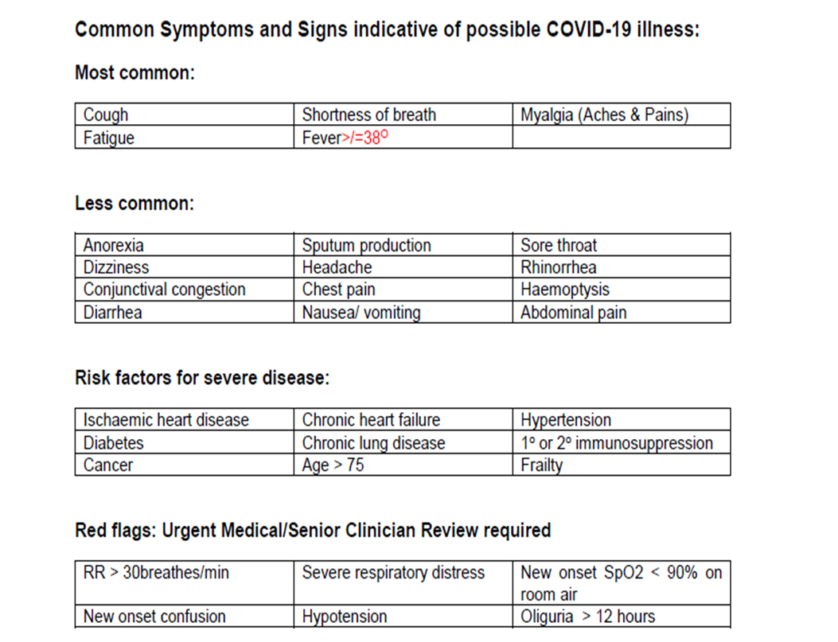

Nursing staff will record each resident’s vital signs, including pulse oximetry twice daily.

Nursing and healthcare staff will observe for known signs of respiratory illness such as cough, complaining of aches and pains, shortness of breath, fatigue or fever.of > 37.5 C or >1.5◦C from usual temperature, (Project Echo Webinar, 16/04/2020)

Staff must also be vigilant in identifying symptoms in older people that may be suggestive of COVID-19, particularly the atypical presentations seen as outlined in Figure 2.

The person in charge will nominate a staff member during the day and at night to measure and record the temperatures of oncoming staff.

All staff must have their temperatures measured and recorded at the start of their shift (HPSC, 17/04/2020)

All oncoming staff must report verbally to their line manager to confirm that they do not have any symptoms of respiratory illness, such as fever, cough, shortness of breath or myalgia. (HPSC, 17/04/2020)

Staff members must adhere to physical distancing when on their breaks and during mealtimes
Figure 2: Guidance from the Regional Geriatric Program of Toronto, 02/04/2020 (cited in Solanki, T 14/04/2020 and Project ECHO AIIHPC: Webinar 16/04/2020 for Nursing Homes) summarises the atypical presentations in older adults:

Typical symptoms of COVID-19 such as fever, cough, and dyspnoea may be absent in the elderly despite respiratory disease.

Only 20-30% of geriatric patients with infection present with fever.

Atypical COVID-19 symptoms include delirium, falls, generalized weakness, malaise, functional decline and conjunctivitis, anorexia, increased sputum production, dizziness, headache, rhinorrhoea, chest pain, haemoptysis, diarrhoea, nausea/vomiting, abdominal pain, nasal congestion, and anosmia.

Tachypnoea, delirium, unexplained tachycardia, or decrease in blood pressure may be the presenting clinical presentation in older adults.

Threshold for diagnosing fever should be lower, i.e. 37.5°C or an increase of >1.5°C from usual temperature

Atypical presentation may be due to several factors, including physiologic changes with age, comorbidities, and inability to provide an accurate history

Older age, frailty, and increasing number of comorbidities increase the probability of an atypical presentation.

Older adults may present with mild symptoms that are disproportionate to the severity of their illness.

Solanki, T (14th April 2020 accessed at https://www.bgs.org.uk/blog/atypical-covid-19-presentations-in-older-people-–-the-need-for-continued-vigilance

Healthcare assistants who note a change in a resident’s general condition or specific signs or symptoms outlined in Fig 2 must report this to the nurse on duty. The healthcare assistant must decontaminate their hands on leaving the resident’s room using the nearest alcohol gel dispenser. The healthcare worker should then report same to the (nurse on duty/clinical nurse manager or specify) in his/her area.

If the resident is not in their room, the healthcare assistant should assist the resident to their room and ask him/her to wait for the (nurse on duty/clinical nurse manager or specify) and then decontaminate his/her hands as outlined in 8.2.2.

The (nurse on duty/clinical nurse manager or specify) must put on personal protective equipment (Appendix 2) before entering the resident’s room/area

The (nurse on duty/clinical nurse manager or specify) will assess the resident and check vital signs , including pulse oximetry and report same to the (PIC/ADON specify)

The (PIC/ADON specify) must be informed of any resident who presents with respiratory illness and / or fever and / or influenza like illness, including cough

Once informed of a resident with symptoms the (PIC/ADON specify) will contact the resident’s general practitioner and following assessment, the general practitioner will make a decision about the need to refer the resident for Covid -19 home assessment and make arrangements for same or instruct a trained member of staff to take swabs.

Protocol for Immediate Response when a Resident is suspected of having Covid -19.

For the purposes of public health action, the threshold for an outbreak of COVID-19 is defined as a single suspected case of COVID-19 in a resident or staff member acquired in the centre or one confirmed case of COVID-19 in a resident or staff member acquired in the centre

When a resident is suspected of having Covid-19, the centre will immediately take initial public health actions as that taken for an outbreak.

The Emergency response coordinator will meet with other members of the emergency response team.

The team will establish and record the following:

The resident’s movements in the last 48 hours.

The resident’s contact with others in the last 48 hours.

The resident’s involvement in communal activities or with others in communal areas in the last 48 hours.

Behavioural characteristics that might increase the risk of transmission from the resident to others.

Any other residents who may be symptomatic and the nature of these symptoms.

Any staff member(s) that may be symptomatic.

Any increase in staff absenteeism.

Any residents and / or staff who were in close contact with the resident in the 48 hours preceding symptom onset or before isolation and transmission based contacts were implemented.

The resident’s GP will contact the Medical Officer of Health (MOH) at the regional Department of Public Health.
    - The person in charge will inform the crisis management team of the local Community Health Office of the outbreak.
    - As of 18/04/2021, the National Public Health Emergency Team adopted the following testing strategy in nursing homes: •

In the event of a case in a nursing home, all residents and all staff should be tested for COVID-19. •

In those nursing homes where there are current outbreaks, all residents and staff who have not yet been, should also be tested. •

In those nursing homes where there are currently no cases, all staff should be tested.

If results for an asymptomatic staff member are ‘indeterminate’, a second test must be ordered immediately. The staff member can continue working while waiting for the test results unless they become symptomatic, (HSE, Workplace Health & Wellbeing Unit, 06/05/2020).
    - The person in charge will nominate two staff members to will complete training to collect samples for testing and include these in the list of contacts during the Covid-19 emergency.
    - Prioritised testing can be arranged through the National Ambulance Service.(HSE and HSPC, 17/04/2020.

The person in charge will notify HIQA of all suspected or confirmed cases of Covid-19 by completing an NF02A form on the HIQA portal, (HIQA, 20/04/2020.

The person in charge will, on a daily basis update HIQA of the number of suspected or confirmed cases of COVID-19 affecting residents and staff. This will be done on the HIQA’s provider portal from 21 April 2020, (HIQA, 20/04/2020.

An Outbreak Control Team (OCT) will be established by the Department of Public Health and arrange for an initial meeting.

Public Health will formulate a case definition and assign an outbreak code for the centre. Public health may decide the visit the centre.

The outbreak team will inform the centre of surveillance activity and records to be kept during the outbreak.

Prior to the initial meeting of the OCT, the emergency response team, under the direction of the ERC will gather and record the following information:

A line list of all residents and staff. Template can be found in Appendix C

Identify the total number of people ill (residents & staff) and the spectrum of symptoms.

Identify staff and residents who have recently recovered, developed complications, been transferred to acute hospitals and those who have died.

Information on laboratory tests available including the number of tests taken to date and the date sent to the laboratory.

Determine if the number of symptomatic residents/staff varies between units/floors/wards or if the outbreak is confined to one unit only.

Use the case definitions for possible, probable and confirmed COVID-19 available on the HPSC website.

Protocol for Resident Suspected or Diagnosed with Covid-19.

The resident’s general practitioner will make a decision as to whether or not the resident’s clinical condition requires hospitalization. This decision will be made in the context of the residents known wishes and preferences recorded or in discussion with the resident as far as he/she is able and the views and observations of family/representative.

Any resident awaiting test or results must be isolated using Contact and Droplet Precautions in addition to standard precautions, (HPSC, 18/04/ 2020 p.22).

The resident should continue to be monitored for changes in condition including twice daily vital signs, increased in accordance with the resident’s condition.

If the test results show that the resident does not have Covid-19, but has a clinical picture of viral respiratory tract infection, additional infection prevention and control precautions (Contact and droplet precautions as per infection control policy) must be maintained to prevent spread of the infection, (HSE, 17/03/2020 p. 3). This should be maintained for at least 48 hours after recovery, (HSE, 21/03/2020, p. 7).

Infection Prevention and Control Measures.

Any resident who is suspected or diagnosed with Covid-19 will be cared for in their room for a minimum of 14 days after the onset of symptoms and with five days free of symptoms.

During this time, the resident will be requested to avoid communal areas.

The resident’s assessments and care plan may need to be updated in accordance with the symptoms present and how the illness is affecting their overall condition, additional needs and care interventions required to meet these needs. For example, the resident may need additional assistance with everyday activities due to fatigue or may need additional interventions to address any risks associated with decreased mobility.

In the event of a commode being used, the staff member should leave the single room wearing full PPE, transport the commode directly to the nearest sluice (dirty utility) and remove PPE in the sluice after placing the contents directly into the bed pan washer or pulp disposal unit. A second person should be available to assist with opening and closing doors to the single room and sluice room. If a second person not available, the staff member must change gloves and perform hand hygiene and put on a clean pair of disposable gloves

If the resident must use a communal toilet, staff must ensure it is cleaned after every use.

Room doors should be kept closed where possible and safe to do so. When this is not possible staff should ensure the resident’s, bed is moved to the furthest safe point in the room to try and achieve a 2m physical distance to the door.

Infection prevention signage must be displayed to reduce entry into the room but confidentiality must be maintained.

Staff should time to explain to the resident the importance of the precautions that are being put in place to manage their care and advise them against leaving their room.

If able and if it is safe for the resident, he/she may go outside alone provided that he/she will be able to maintain a distance of at least 1m from others.

If the resident wishes to go outside and needs to be accompanied by a staff member, the staff member accompanying the resident will need to wear a surgical face mask if he/she cannot maintain a distance of at least 2 m from the resident and if the staff member needs to have close personal contact, he / she will need to also wear apron and .gloves

If the resident transits briefly through a hallway or other unoccupied space to go outside, there is no requirement for any additional cleaning beyond normal good practice (HPSC, 18/04//2020)

If the resident does need to go through an occupied shared space to go outside, he she must be encouraged to wash his/her hands beforehand and wear a surgical mask or cover the mouth and nose with a tissue.

All staff in the centre should ensure they adhere to standard precautions and increase attention to hand hygiene and respiratory/cough etiquette. All healthcare workers must wear surgical masks if they are within 2m of a patient, regardless of the COVID-19 status of the patient (HSPC, 21/04/2020).

Surgical masks should be worn by all healthcare workers for all encounters, of 15 minutes or more, with other healthcare workers in the workplace where a distance of 2m cannot be maintained, (HSPC, 21/04/2020).
Practical Considerations:
Staff will need to put on PPE before entering the affected area so an area just inside the resident’s room will need to be designated for this purpose. This means for example, having an area in the room, at least 2m from the resident and their immediate surroundings, where staff can put on and remove PPE. This area will need to have a clinical waste bin or bag, PPE and alcohol gel.
Also, surgical masks are the last item of PPE to be removed and must be removed outside the affected area. In practice, this means that a healthcare risk waste bin or bag must be located outside the affected are (resident’s room). Alcohol gel must also be available at this point as the staff member will need to clean their hands prior to and after removal of the surgical mask.

Use of personal Protective Equipment, (HSE, 17/04/2020)

Personal protective equipment in use for infection prevention and control for suspected and confirmed cases of Covid-19 include:

Disposable single nitrile gloves.

Disposable plastic aprons. are recommended to protect staff uniform and clothes from contamination when providing direct patient care and when carrying out environmental and equipment decontamination.

Surgical Face Mask (Fluid Resistant Type 11R./FFP2 for aerosol generating procedures(HPSC, 17/04/2020.

Long sleeved Fluid Resistant disposable gowns are recommended when there is a risk of extensive splashing of blood and or other body fluids and a disposable plastic apron does not provide adequate cover to protect HCWs uniform or clothing. If non- fluid resistant gowns are used and there is a risk of splashing with blood or other body fluids a disposable plastic apron should be worn underneath.

Eye protection Eye protection/Face visor: should be worn when there is a risk of contamination to the eyes from splashing of blood, body fluids, excretions or secretions (including respiratory secretions). These include goggles and safety glasses, full face shield or visor and surgical face mask with integrated visor.

In outbreak situations or other circumstances where extended use of one set of PPE (other than gloves) when moving between patients with a diagnosis of COVID-19, it is important to make every effort to avoid generalised use of PPE throughout the facility without considering the level of risk, (HPSC, 17/04/2020

In the event of extended use of PPE define clean and contaminated zones. PPE should be donned before entering the contaminated zone and doffed and hand hygiene before entering clean zones (HPSC, 17/04/2020

Where staff are having meals on a unit to minimise staff interaction, it is essential that the staff refreshment area is a clean zone. Corridors between units should be designated clean zones. Clinical stations should normally be clean zones, (HPSC, 17/04/2020

Staff with long hear should keep their hair tied up and off their face.

When wearing a surgical face mask, it

Must cover the nose and mouth of the wearer

Must not be allowed to dangle around the HCWs neck after or between each use

Must not be touched once in place

Must be changed when wet or torn

Must be worn once and then discarded as health care risk waste (as referred to as clinical waste)
Please refer to Appendix 1 for HSE (17/04/2020) Guidance on use of PPE in specific situations.

Standard precautions should continue to be used in clean areas and units not affected by the outbreak. This includes

Performing hand hygiene before and after every episode of resident contact (5 moments),

The use of PPE (including gloves, gown, appropriate mask and eye protection) depending on the anticipated exposure,

Good respiratory hygiene/cough etiquette and

Regular cleaning of the environment and equipment.

Frequent hand hygiene should be carried out using alcohol based gels when hands or not soiled.

If hands are visibly soiled or have been in contact with bodily fluids, they should be washed with liquid soap and running water and then dried with a disposable paper towel.

Staff should be encouraged to do refresher infection control training.

Adequate hand hygiene facilities with either alcohol based gels or hand wash basins with liquid soap, water and paper towels must be available. In additional hand hygiene facilities should be located:

In each resident bedroom.

Outside each resident’s bedroom so that’s hands can be cleaned following removal of surgical masks.

At entrances to and exits from areas where residents are being cohorted due to suspected or confirmed COVID-19.

At entrance to the centre.

Staff should encourage residents to wash their hands when leaving their room, before and after meals and after toileting. Residents who need assistance should be assisted with hand hygiene.

Respiratory and Cough Etiquette.

Staff must adhere to good cough and sneeze etiquette, including coughing or sneezing into their elbow or a tissue and disposing of the tissue into a foot operated waste bin and then cleansing the hands.

Staff must encourage respiratory and cough etiquette among residents and any essential visitors to the centre.

Some residents may need assistance with containment of respiratory secretion. Those who are immobile will need a waste bag at hand for immediate disposal of the tissue such as a bag. Hands should be cleaned with either soap and water or an Alcohol Based Hand Rub (ABHR) after coughing sneezing, using tissues or after contact with respiratory secretions and contaminated objects (HPSC, 17/04/2020).

Staff and residents should be advised to keep hands away from their eyes, mouth and nose.

Transmission Based Precautions.

In addition to standard based precautions, transmission based precautions must be initiated. For all suspected cases of Covid-19. These includes use of the right PPE in the right circumstances as outlined in Appendix 2.

Necessary PPE should be available immediately outside of the resident room and in other areas where resident care is provided (CDC, 2020).

Clinical waste disposal bins should be positioned near the exit inside of the resident room to make it easy for staff to discard PPE after removal, prior to exiting the room, or before providing care for another resident in the same room (CDC, 2020).

The (pic/adon/specify) must ensure that staff know how and when to use the right PPE in the right circumstances. This includes knowing how to put on and take off PPE.

Staff should generally change their PPE and perform hand hygiene after every contact with an ill resident, however, in the current exceptional circumstances, if caring for a cohort group of residents with a diagnoses of COVID-19, and not caring for other residents, limiting this to a change of gloves and hand hygiene between individual residents is acceptable if the PPE is not wet, soiled or damaged.
When cohorting residents with COVID-19 on a unit, floor, all staff entering the area, who are not working solely in the area, such as kitchen staff delivering and collecting trolleys, should wear PPE. This would include nitrile gloves and plastic aprons. A risk assessment should be carried out for areas where residents may be walking on corridors, such as a resident with cognitive impairment/dementia. In such cases, staff coming to the area need to wear a surgical mask. These staff members should remove their PPE when leaving the area and wash their hands. The surgical mask is the last item to be removed and is removed outside the affected area. Hands must be cleansed before and after removing the surgical mask.

Environmental Cleaning (HPSE, 17/04/2020)

The care environment should be kept clean and clutter free in so far as is possible bearing in mind this is the resident’s home.

Residents observation charts, medication prescription and administration records (drug charts) and healthcare records should not be taken into the room to limit the risk of contamination.

Routine cleaning

Decontamination of equipment and the care environment must be performed using either:

A combined detergent/disinfectant solution at a dilution of 1,000parts per million available chlorine (ppm available chlorine (av.cl.)); or

A general-purpose neutral detergent in a solution of warm water, followed by a disinfectant solution of 1,000 ppm av.cl.

Only cleaning (detergent) and disinfectant products supplied by employers are to be used. Products must be prepared and used according to the manufacturer’s instructions and recommended product "contact times" must be followed

Hoovering of carpet floor in a resident’s room should be avoided during an outbreak and while the patient is infectious. When the resident is recovered the carpet should be steam cleaned.

All shared spaces should be cleaned with detergent and disinfectant.

Equipment used in the cleaning/disinfection of the isolation area should be single-use where possible and stored separately to equipment used in other areas of the facility.

Household and care staff should be trained in the appropriate use and removal of PPE In practical terms isolation room cleaning may be undertaken by staff that are also providing care in the isolation room.
(HPSC, 18/04/2020).

Frequency of cleaning

All surfaces in resident room/zone should be cleaned and disinfected twice daily and when contaminated. These include bedrails, bedside tables, light switches, remote controllers, commodes, doorknobs, sinks, surfaces and equipment close to the resident e.g. walking frames, sticks. Handrails and table tops in facility communal areas, and nurses station counter tops.

The resident rooms, cohort areas and clinical rooms must be cleaned and disinfected at least daily and a cleaning schedule should be available to confirm this.

Terminal cleaning

Terminal cleaning should always be performed after a resident has vacated the room and is not expected to return. In addition to the routine cleaning protocols, a terminal clean is needed, including:

Removal of all detachable objects from a room or cohort area, including laundry and curtains;

Removal of waste;

Cleaning (wiping) of lighting and ventilation components on the ceiling;

Cleaning of the upper surfaces of hard-to-reach fixtures and fittings;

Cleaning of all other sites and surfaces working from higher up to floor level.

The terminal clean checklist should be completed, which should be signed off by the cleaning supervisor before the room reopens for occupancy.

Staff uniforms/clothing

Staff uniforms are not considered to be personal protective equipment.

Uniforms should be laundered daily and separately from other household linen; in a load not more than half the machine capacity at the maximum temperature the fabric can tolerate then ironed or tumble dried.

Staff should avoid bringing personal items, including mobile phones into isolation or cohort areas See Fig 3 for Tips for Arriving Home Safely.

Staff are advised to wear designated shoes for work that can be left at the centre.

Resident Care Equipment.

Where possible, single use, disposable equipment will be used and should be disposed of as healthcare risk waste inside the resident’s room.

If re usable resident care equipment is in use, ideally it should be dedicated for the use of an individual resident. If this is not feasible, equipment should be cleaned and disinfected immediately following use between each resident use.

Figure 3: Tips for Arriving Home Safely.
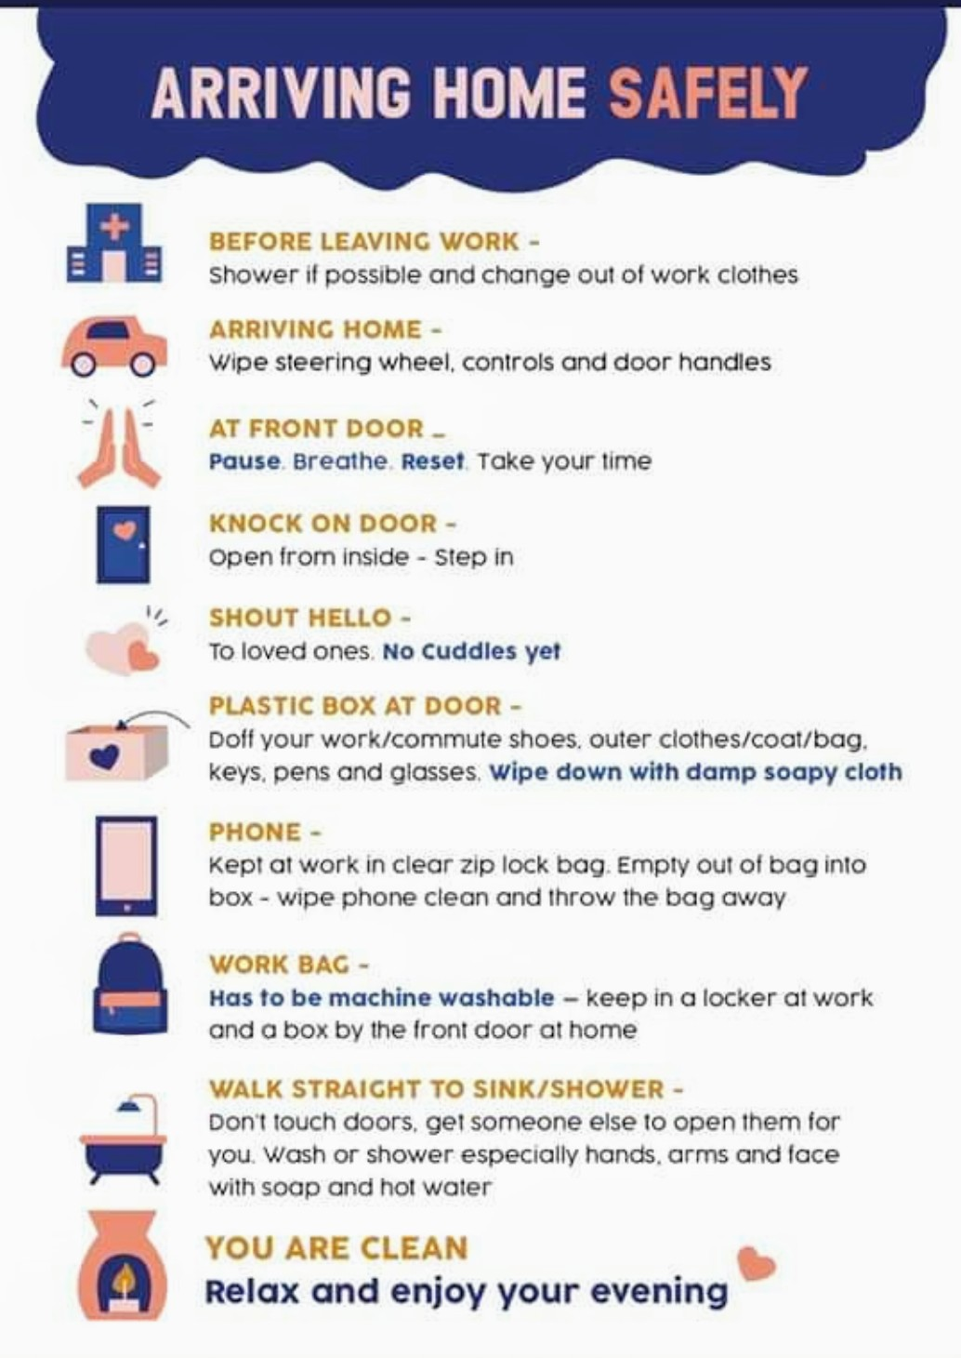

Linen.

All towels, clothing or other laundry used in the direct care of residents with suspected and confirmed COVID-19 must be treated as ‘infectious’ linen.

Linen must be handled, transported and processed in a manner that prevents exposure to the skin and mucous membranes of staff, contamination of their clothing and the environment.

Disposable gloves and an apron should be worn when handling linen.

All linen should be handled inside the resident room/cohort area. A laundry skip/trolley should be available as close as possible to the point-of-use for linen deposit, for example immediately outside the cohort area/isolation room.

When handling linen, the staff should not:

rinse, shake or sort linen on removal from beds/trolleys;

place used/infectious linen on the floor or any other surfaces (e.g., a bedside locker/table top);

handle used/infectious linen once bagged;

overfill laundry receptacles; or

place inappropriate items in the laundry receptacle (e.g., used equipment/needles)

When managing infectious linen, the staff should:

Place linen directly into a water-soluble/alginate bag and secure;

Place the alginate/water-soluble bag into the appropriately-coloured (red) linen bag

Store all used/infectious linen in a designated, safe area pending collection (specify).

Laundry should be washed using the hottest temperature that the fabric can withstand and standard laundry detergent.

Laundry should be dried in a dryer on a hot setting.

Crockery and Cutlery.

Crockery and cutlery from affected residents should be washed in a hot dishwasher.

There is no need to separate the crockery and cutlery being used by affected residents from that of other residents.

Signage.

Infection prevention and control signage should be placed at entrances and other strategic locations to alert staff, residents and essential visitors to provide information on the required infection prevention and control precautions.

Droplet precaution signs must be placed outside symptomatic residents’ rooms to alert staff and essential visitors to the requirement for transmission-based precautions.

Admissions and Transfers

Patient Transfer

Transfer to hospital should only be carried out:

In accordance with the resident’s known wishes and preferences outlined in discussions with the resident or where the resident is unable with the resident’s family/representative. Benefits and risks associated with transfer to hospital should be discussed by the resident’s general practitioner and recorded in the resident’s healthcare record.

For essential care that is deemed clinically appropriate and will provide a beneficial outcome for the resident.

Nursing staff must advise the hospital and transport provider in advance that the resident is being transferred from a facility where there is potential or confirmed COVID-19.

Any resident requiring hospitalization who has suspected or confirmed COVID-19 should wear a surgical mask during transfer.

New admissions and Re admission

New admissions and return of residents may occur during an outbreak subject to an assessment of the needs of the resident and the extent and status of the outbreak and the ability of the centre to protect new admissions and returning residents from exposure to infection.

Wherever possible, every resident transferred from an acute hospital to the centre should be accommodated in a single room with droplet precautions for 14 days after transfer and monitored for new symptoms consistent with COVID-19 during that time.(The rationale for this recommendation is that, in the context of a pandemic, there may have been contact between the resident and other residents or healthcare workers etc. who may have had COVID-19 infection but who may have been in the pre-symptomatic incubation period or have had minimal symptoms prior to COVID--19 being diagnosed, with the associated risk of unrecognised onward transmission to the resident), (HPSC, 17/04/2020)

According to the HPSC, 17/04/2020, if accommodation in a single room for every newly-transferred resident is not possible, the following measures might also be considered:

Placing the new resident in a room with a resident who has recovered from laboratory confirmed COVID-19 infection and has completed their isolation period.

The new resident should remain on droplet precautions.

If there is another resident who is not known to have had COVID infection also being transferred from the acute hospital setting they can both be cohorted together for 14 days, with droplet precautions for both during this time.

All transfers/admissions with fever or symptoms of acute respiratory tract infection should be accommodated in their own room with en-suite toilet facilities and treated as a COVID-19 case (HPSC, 17/04/2020)

People with confirmed COVID-19 should not be transferred to a residential care facility until 14 days after onset of symptoms with the last 5 days free of fever.

For those hospitalised patients with a persistent positive PCR test for COVID-19, IPC precautions should be kept in place for another 7 days (i.e. for a total of 21 days) and then removed, provided the patient has no symptoms consistent with ongoing COVID-19 infection at this point. No further retesting is required, as the risk of transmission is extremely low at this point. After 21 days, they can then be discharged from hospital to residential settings, if well enough for discharge, (HSPC, 04/05/2020)

Residents who fulfil the above criteria are not infectious and do not need any special considerations in terms of placement within the centre (HPSC, 17/04/2020

Cohorting residents with possible or confirmed COVID-19.

Residents with possible or confirmed COVID-19 will be cared for in a dedicated ZONE with dedicated staffing and equipment, as far as is possible, to facilitate care and minimise further spread.

Residents with probable or confirmed COVID-19 will be isolated in single rooms with en-suite facilities and where there are multiple residents, these single rooms will be located in close proximity to one another in one zone for example on a particular floor or area within the facility.

Where single room capacity is exceeded and it is necessary to cohort residents in a multi-occupancy room; only Residents with a diagnosis of COVID-19 will be cohorted together;

Residents with probable COVID-19 will not be cohorted with those who are confirmed positive;

Where residents are cohorted in multi-occupancy rooms , the following measures will be put in place to prevent transmission:

Beds will be arranged to allow the maximum physical distance as possible between beds including reduce the number of residents/beds in the area to facilitate social distancing.

Privacy curtains will be used between the beds to minimize opportunities for close contact.

Clear signage will be erected to alert staff of all cohorting zones.

A designated cohort area will be separated from non-cohort areas by closed doors.

Movement of staff in cohort areas will be kept to a minimum through changes to duty hours and rostering of staff.

Rostering will aim to ensure that staff working in cohort areas are not be assigned to work in non-COVID-19 areas.

In so far as is possible, alternative routes will be identified for staff, visitors and residents to ensure that cohorting zones will not be used as a thoroughfare by other residents, visitors or staff, including residents being transferred, staff going for meal breaks and staff entering and exiting the building.

Wearing of PPE by staff should adhere to HSE guidance in Appendix 1

Nursing Care of the Resident with Suspected or Confirmed Covid-19.

As previously outlined, residents who have suspected or confirmed Covid-19 illness need to have additional infection prevention control measures in place .

The daily care of the resident will vary in accordance with individual needs resulting from any existing diagnoses and health conditions as well as the impact of the illness on the resident.

Vital signs should be monitored at least twice daily for residents with suspected Covid-19 to identify any changes in their clinical condition and progression of illness. This should be increased as required based on the resident’s overall condition and as advised by the resident’s GP. Vital signs should include checking of temperature, blood pressure, pulse, respiratory rate and pulse oximetry.

Care of a resident with Covid-19 should be delivered by a single nominated healthcare assistant during each shift.

Nursing interventions should aim at

Management of symptoms, including fever, shortness of breath, fatigue, generalized aches and pains. This includes administration of prescribed medications for symptoms.

Identifying potential problems and risks specific to the illness itself and to its impact on the resident. These for example may include risks related to skin integrity/pressure ulcer risk, risks resulting from prolonged time spend in bed such as predisposition to deep vein thrombosis for those with circulatory problems, dehydration, delirium, constipation and so on.

Recognising and managing delirium

Optimizing the resident’s fluid and nutritional intake. This may involve the use of subcutaneous fluid infusions.

Addressing psychosocial needs arising from not being able to see family members, friends or being involved in group activities with other residents, such as loneliness, anxiety, boredom. Use of technology, such as Skype, facetime could assist with maintaining contact with family and friends outside of the centre.

Educating the resident on handwashing, maintaining distance of at least 1m from others if going outside, use of surgical mask and any other measures needed to maintain optimum health such as the need for fluids and nutrition.

Recognising and responding appropriately to acute changes in condition.

Palliative and end of life care where a resident reaches this stage of illness.

Rapid and unexpected change in clinical status may occur typically between day 7 to 9 of the illness, which can result in the resident’s condition deteriorating and the need for additional care. Decisions regarding interventions to meet changes in condition should be individualized to each resident in liaison with the resident’s general practitioner and other relevant healthcare professionals. These decisions should be informed by the resident’s known wishes and preferences for what to do in the event of a sudden deterioration in their condition and their end of life care plan as appropriate.

Acute changes in a resident’s clinical status must be reported to the (person in charge/adon/specify) who will liaise with the resident general practitioner to determine what interventions are required.

Recognising and Responding to Sepsis.

Sepsis is a life-threatening condition triggered by infection that affects the function of the organs. It is treated most effectively if recognised early.

It can affect anyone but is more common in the very young, the elderly or those with a weakened immune system.

Sepsis and septic shock can result from an infection anywhere in the body, such as pneumonia, influenza, or urinary tract infections. Bacterial infections are the most common cause of sepsis.

Signs and symptoms of sepsis include:

Fever> 38°C.

Hypothermia ≤ 36

Rigors/Shivering.

Confusion

Shortness of breath.

Rapid breathing > 20 per minute.

Rapid heart rate > 90 per minute.
Sepsis Alliance: Ageing accessed 31/03/2020.

Where a resident with COVID 19 develops the above symptoms, the nurse should report these without delay to the (CNM/ADON/PIC specify) and the residents GP must be informed.

The GP and (CNM/ADON/PIC specify) will make a decision about the most appropriate intervention, including the need for hospital transfer, in accordance with the resident’s known wishes and preference and / or the views and observations of the family where appropriate.

Hospital transfer of a resident during a COVID 19 outbreak is considered where the transfer is likely to provide benefit to the resident.

Recognising and Caring for Residents with Delirium.

Older people are at the greatest risk from COVID-19. If infected they may present with or develop a delirium. Older people are at the greatest risk from COVID-19. If infected they may present with or develop a delirium. The British Geriatrics Society, (2020) offer the following advice:

Reduce the risk of delirium by avoiding or reducing known precipitants. Actions include: regular orientation, avoiding constipation, treating pain, identification and treatment of superadded infections early, maintaining oxygenation, avoiding urinary retention and medication review.

With respect to behavioural disturbance, always look for and treat direct causes including pain, urinary retention, constipation, etc.

Older adults, especially in isolation and those with cognitive decline/dementia, may become more anxious, angry, stressed, agitated, and withdrawn during the outbreak/while in quarantine. Provide practical and emotional support through informal networks (families via Skype) and health professionals.

Share simple facts about what is going on and give clear information about how to reduce risk of infection in words older people with/without cognitive impairment can understand. Repeat the information whenever necessary. Instructions need to be communicated in a clear, concise, respectful and patient way. and it may also be helpful for information to be displayed in writing or pictures. Engage their family and other support networks in providing information and helping them practice prevention measures (e.g. handwashing etc.). See also Figure 4:Tips for managing Delirium.
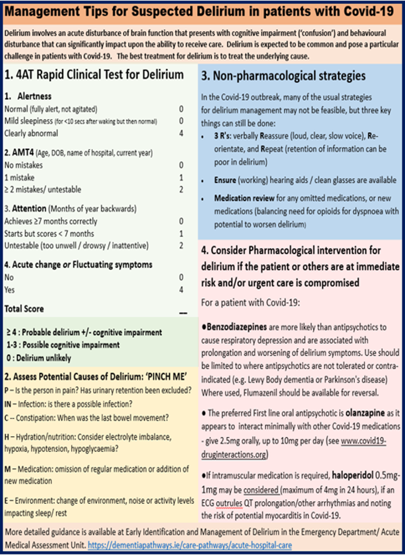
Figure 4: Tips for managing Delirium

Care of Residents Identified as Covid-19 contacts.

Any resident who is identified as a Covid-19 contact will be accommodated in a single room with their own bathing and toileting facilities, or if this is not possible, cohorted in groups of 2 to 4 with other contacts.

Residents who are Covid-19 contacts will be requested to avoid communal areas and stay in their room for a period of observation lasting 14 days after exposure and until Public Health advice confirms that the resident can resume normal activity.

If the resident who is a contact needs to enter an occupied shared space, he/she should be encouraged to perform hand hygiene and wear a surgical mask or cover his/her mouth with a tissue.

If a resident who is a contact transits briefly through a hallway or unoccupied space to go outside, there is no requirement for additional cleaning of that area beyond normal good practice.

Residents may go outside if appropriate, alone or accompanied by a staff member maintaining a distance of 1m. The staff member in this scenario does not need to wear PPE.

Testing of residents who are Covid-19 contacts is not appropriate unless they develop symptoms of infection. If the resident develops symptoms of infection, they should be referred to their general practitioner for assessment.

Care of residents who are identified as Covid-19 contacts should adhere to their existing care plans, but additional interventions to address psychosocial needs related to restrictions should be addressed in accordance with the individual resident’s needs and preferences.

Management of Staff.

All staff receive education/training on infection prevention and control as part of the mandatory training programme for the centre.

Updates will be provided to staff on infection prevention and control for cases of suspected or confirmed diagnosis of Covid-19 and management of outbreaks. This will include use of resources and videos available on both the HSE and HSPC websites. Training will include information on the use of PPE as well as instructions on how to put on and take off PPE.

Staff will be informed of the need to practice hand hygiene, cough and respiratory etiquette and the importance of not touching their face.

Staff will be informed of the importance of self-monitoring for signs and symptoms of respiratory illness, particularly, fever, cough, shortness of breath and / or fatigue.

Staff Wellness.

Staff will be provided with information about resources for staff wellness

Staff Members Identified as Close Contacts.

A log of all staff involved in the care of a resident suspected or diagnosed with Coronavirus, or who fulfil the definition of a contact, will be maintained in these residents’ rooms , (HSE, Workplace Health & Wellbeing Unit, 06/05/2020).

Staff members will sign in and out on these logs. These will be deemed ‘Casual Contacts’, unless any staff member meets the criteria for close contact as per 22.1.3.

Staff members who meet the criteria below are considered close contacts:

have a cumulative unprotected exposure during one work shift (i.e. any breach or omission of gloves, a gown, eye or respiratory protection) for more than 15 minutes face-to-face (< 1 meters distance) to a case

OR have any unprotected exposure of their eyes or mouth or mucus membranes, to the bodily fluids (mainly respiratory secretions e.g. coughing, but also includes blood, stools, vomit, and urine) of the case. OR

have any unprotected exposure (i.e. any breach in gloves, gown, eye or respiratory protection) while present in the same room when an aerosol generating procedure* is undertaken on the case.

Staff members who have been identified as being close contacts of a confirmed case outside of the work environment.
(HSE, 19/03/2020, p. 8).

Any staff member who meets the above criteria as a close contact must inform the (person in charge/ADON/specify)

Staff members who have been identified as close contacts will be unable to remain at / return to work (HSE, 17/04/2020).

These staff members will be advised to self quarantine for 14 days from the last date of contact with the confirmed case .If during this time, the staff member develops symptoms, he/she should self-isolate for 14 days from the onset of symptoms and may not return to work until at least 14 days after complete resolution of symptoms and with at least 5 days with no fever (HSE, 17/04/2020, p. 8).
    - If they remain asymptomatic throughout the monitoring period, they will not require testing and may return to work after 14 days

Managing staff members who are casual contacts , (HSE, Workplace Health & Wellbeing Unit, 06/05/2020).

19.4.1 Asymptomatic Casual Contacts Can remain at Work, but symptomatic Casual Contacts Must not remain at work

Casual Contact specific advice will be provided to staff identified as casual contacts.

Staff identified as casual contacts should self-monitor for symptoms for 14 days after the last potential exposure as well as having their temperatures checked each day while on duty.

Staff must report immediately to the (person in charge/ ADON/specify) if they have any of these symptoms and will be advised to go home immediately, self-isolate and to contact their GP for advice re testing. If the staff member cannot go home immediately, they must be isolated in a separate room until they can go home.

Staff must not present for work if they have any signs or symptoms of respiratory illness and should self-isolate and contact their GP.

If a staff member is diagnosed with Covid-19, he/she must not return to work until at least 14 days after complete resolution of symptoms and with at least 5 days with no fever (HSE, 17/04/2020).

If the staff member does not have Covid-19, but has another respiratory infection, he/she must not return to work until fully recovered for at least 48 hours. (HSE, 21/03/2020, p. 8).

The following staff must not be rostered to work with residents that are suspected or confirmed as having Covid-19:

– Those for whom it has not been possible to identify and provide appropriately fitting PPE.

– Staff members who are pregnant or immunocompromised secondary to illness or treatment, and

Staff members who have indicated they would like to be redeployed.

Staff caring for residents with suspected or COVID 19 should consider the following measures when returning home in order to minimize the risk of transmission to other household members:

Practice physical distancing.

Wash hands frequently.

Clean the frequently touched surfaces in their car eg. Steering wheel, knobs, screens etc.

Family members of health care workers currently involved in the care of COVID 19 residents should:

Practice physical distancing.

Consider sleeping in a separate room and using a separate bathroom if they belong to a high risk group.

Wash hands meticulously.

If a healthcare worker has returned from international travel (outside of the island of Ireland) he/she must be excluded from work for a period of 14 days on passive monitoring. If during this period, the staff member develops any symptoms of respiratory illness, they should self-isolate, contact their general practitioner for advice and not return to work until at least 14 days after complete resolution of symptoms and with at least 5 days with no fever (HSE, 21/03/2020, p. 8). Guidance for staff on self-quarantine and self-isolation at home is available on the HPSC website https://www.hpsc.ie/az/respiratory/coronavirus/novelcoronavirus/guidance/selfisolationathome/

Staffing Plans and Rostering.

Contingency plans for Covid-19 are in place. These include:

Sourcing of bank staff who will be on call to cover staff shortages that may result from the need for staff to self isolate. These include staff members who have retired from the centre as well as those staff who have applied for positions through the Nursing Homes Ireland recruitment portal.

Rostering of nominated nursing and care staff per shift to care for a resident(s) who are suspected of having Covid-19; residents who are identified as Covid 19 contacts and residents with Covid 19.

Rostering will be cognisance of the additional needs of residents who are acutely unwell.

Where required, accommodation for staff can be provided in the following locations:
(specify)

Monitoring the Outbreak.

The centre will monitoring the outbreak through ongoing surveillance to identify new cases and to update the status of ill residents and staff.

The (specify) will update the line listing with new cases or developments as they occur and communicate this to the OCT on a daily basis or more frequently if major changes occur in line with Public Health recommendations until the outbreak is declared over.

Review of this information will be carried out the by emergency response team and the OCT to monitor and review the effectiveness of control measures in place and make changes to measures as appropriate.

Daily surveillance for fever or respiratory symptoms, including cough, in residents and staff will continue for 28 days after the date of onset of symptoms of the last resident COVID-19 case.

Declaring the outbreak over.

In order to declare that the outbreak is over, the facility should not have experienced any new cases of infection (resident or staff) which meet the case definition for a period of 28 days (HPSC, 17/04/2020).

The (person in charge/adon specify) will liaise with the OCT to declare the outbreak over.

End of Life Care.

Residents at end of life stage should be cared for according to the Centre’s end of life policy.

A review of end of life care plans will be undertaken in the preparation phase of the COVID-19 emergency.

Advance care plans should include decisions about whether hospital transfer would be considered (for oxygen therapy, intravenous fluid and antibiotics) for COVID-related illness

Advance care plans should be shared with the primary care out-of-hours service. Primary care providers should consider how to respond in a timely fashion.

Where a resident is at the advanced stages of a life limiting condition and has already been moved to a palliative approach, care should continue in accordance with their end of life care plan and known wishes and preferences previously recorded.

Where the resident is at the palliative care stage of their illness, the ADON should liaise with the resident’s GP or palliative care team about anticipatory prescribing for end of life symptoms.

Where a resident who is not at the advanced stages of a life limiting illness becomes very ill because of COVID 19, their GP must be informed and decisions about interventions must be made by the resident’s GP, involving the resident as far as he/she is able and the views and observations of family as appropriate.

Symptom management for residents with Covid 19 receiving end of life care is provided in Appendix 3.

Visitors.

The presence of a person close to the resident will be facilitated as far as is possible.

Decisions about visitation during an end of life situation should be made on a case by case basis, which should include careful screening of the visitor for fever or respiratory symptoms. Those with symptoms should not be permitted to enter the facility.

Potential visitors must be informed of the potential risk of infection and the need to self quarantine for 14 days after visiting

Those visitors that are permitted must wear a facemask and apron while in the building and restrict their visit to the resident’s room or other location designated by the Centre. They should also be reminded to frequently perform hand hygiene, (HSPC, 17/04/2020; CDC, 2020).

Visitors should be instructed on how to put on and take off the PPE & how to perform hand hygiene. Where practical visitors should be supervised when donning and doffing PPE.

For the anointing of the sick or other rites where only transient physical contact is required, gloves are not necessary so long as hand hygiene is performed immediately after anointing or touching the person (HSPC, 17/04/2020).

Visitors should avoid contact with people other than the person they are accompanying.

Use of Oxygen.

According to the Interim Guidance on the use of oxygen in long term residential care settings for older people during the COVID 19 pandemic V.309/04/2020 –
‘The primary pathology causing death in patients with COVID 19 is respiratory failure as a result of a viral pneumonia. Viral myocarditis has also been reported as a cause of up to one third of deaths. Secondary bacterial infections are rarely reported. Death is more common in those with significant frailty or co-morbidities with lower physiological reserve.
In the absence of effective anti-viral therapy, management in any setting is primarily symptomatic and supportive. As the disease can progress rapidly or unexpectedly, advance care plans including decisions on ceilings of care should be documented in advance of decisions regarding oxygen treatment.

The role of supplemental oxygen
Recent evidence suggests that supplemental oxygen has only a limited role in the management of COVID 19 in care settings outside acute hospitals. Oxygen may have some value in supporting patients with respiratory and cardiac morbidity, where it should be titrated against oxygen saturation levels and knowledge of background co-morbid disease, in particular COPD where Type 2 respiratory failure is more common.
There is consensus amongst palliative care physicians that oxygen does not typically improve symptoms of breathlessness at end of life where the approach should instead be the provision of appropriate supportive palliative medications (see CG Management of severe breathlessness). This often needs to be explained to carers and relatives
Prescribing oxygen
Oxygen is a treatment for hypoxia and should be prescribed in the medication Kardex by the registered medical practitioner or nurse prescriber. All changes to prescription / flow rate must be discussed with the prescriber.
Maximum titration flow in care settings outside hospital is 4 l / min. When supporting a patient with Covid 19 for recovery with oxygen, supplementary oxygen can be commenced when saturations are less than 94%. The oxygen should then be titrated to achieve a target of 94%-96% in those patients who do not also have COPD.
In patients being treated for Covid-19 with a co-morbidity of COPD, oxygen saturations should be targeted at 90 - 94% due to the risk of Type 2 respiratory failure’.

Death of a Resident and Last Rites.

This procedure must be followed in the event of the death of a resident in Centre, including last rights is outlined in the centre’s End of Life Policy. The following additional measures are required for the death of a resident suspected or confirmed as having COVID-19.

Verification of the residents death
SCENARIO 1: Death where a resident was suspected as having COVID-19 however this has not been confirmed as the resident was still awaiting testing.

Report the death to the District Coroner

Transfer body to mortuary if the Coroner so directs or in accordance with established out of hours procedures.

Post mortem viral swabs may be taken at the direction of the Coroner.

Whilst awaiting swab results, the body may be released by direction of the Coroner if the doctor confirms the cause of death as being due to natural causes and there are no other circumstances requiring further investigation or examination. The actual cause of death to be certified by the doctor on the Death Notification Form will need to be confirmed with the Coroner’s office once the swab result is available.

e) If positive, in most cases a postmortem examination will not be required unless other circumstances are present and the law mandates an autopsy to be directed by the Coroner.

f) If negative and the body has not already been released by direction of the Coroner where the doctor has confirmed the cause of death as being due to natural causes and there are no other circumstances requiring further investigation or examination, the need for post mortem examination will only be required if the Coroner so directs based on the clinical and other circumstantial information applying the law accordingly.
SCENARIO 2: Death of a resident where there has been a previously confirmed outbreak of COVID-19 in the Centre.

Report the death to the District Coroner.

b) The Coroner may release the body if he or she is satisfied that the cause of death is due to natural causes, and there are no other circumstances requiring further investigation or examination. This will include in cases where an ante mortem swab has been taken and the result has not yet been returned.

The actual cause of death to be certified by the doctor will need to consider the preceding medical history and circumstances, and to be confirmed with the Coroner’s office.

Pronouncement of death by a registered nurse during Covid-19 Emergency.

On the 30/04/2020, the HSE published the INTERIM CLINICAL GUIDANCE FOR THE PRONOUNCEMENT OF DEATH BY REGISTERED NURSES IN IDENTIFIED SERVICES IN THE CONTEXT OF THE GLOBAL COVID-19 PANDEMIC.

Where pronouncement of death by registered nursing is being carried out, it should comply with the centre’s pronouncement of death by a registered nurse in Covid-19 policy.

Last Rites

Staff are advised the door to the deceased resident’s room be closed with a time of closure recorded on a notice on the door. Following a 1hour period (allowing for droplets to settle). staff can enter the room to provide last rites care.

At a minimum staff should wear the following:
- Nitrile gloves
- Long sleeved water resistant gown

Where there is a risk of splashing during last rites, staff should also take droplet precautions i.e. surgical mask and goggles.

A face mask should be placed over the mouth of the deceased resident prior to commencing care of the body.

Hygiene preparation should be carried out including washing of the face and hands, closing the mouth and eyes, tiding the hair and in some cases shaving the face (HPSC, 18/04/2020).

The plugging of orifices to prevent discharge is not permitted for infectious diseases (HPSC, 2013).

In accordance with HSPC (2013, page 17) in the case of |Hazard Group 4 infections such as COVID-19, wounds should not be covered, and all drains, catheters and intravenous lines should not be removed. Drainage sites should not be covered with a dressing.

If the relatives want to wash or prepare the body for religious or cultural reasons, the nurse should advise the family members / religious leader / representative of the need to wear PPE consisting of a long-sleeved gown, gloves, a surgical facemask and eye protection if there is a risk of splashing (HSPC, 18/04/2020)

Last offices and removal from the clinical area should be carried out by a minimum number of staff.

Viewing of the deceased resident is permitted only for those relatives who have been screened prior to visiting. Visitor numbers must be restricted due to the risk of spread of infection.

Preparation of Removal to the Funeral Home / Mortuary

Those physically handling the body and placing the body into the coffin or the inner lining should wear, at a minimum, the following PPE:

Gloves

Long sleeved gown

Surgical face mask and

Pay close attention to hand hygiene after removal of PPE.

Ensure the deceased residents is wearing a facemask.

The family should be advised not to kiss the deceased and should clean their hands with alcohol hand rub or soap and water after touching the deceased (HPSC, 17/04/2020)

The deceased resident’s body should be wrapped loosely in a clean sheet and secured with tape.

The remains must be placed into a body bag and the bag zipped up fully. The bag should not be reopened once closed to reduce the risk of infection.

Terminal Cleaning.

Following removal of the remains from the room, the area will require terminal cleaning.

Staff must wait an hour before cleaning the room.

All equipment and surfaces should be cleaned using detergent and disinfected using disinfectant active against viruses or a 2 in 1 solution.

For equipment, staff should check manufacturer’s instructions to ensure that the products in use are compatible with the instructions for cleaning and disinfecting the equipment.

Cleaning and disinfecting the room must include:

Top, front and sides of the bed’s headboard, mattress, bedframe, foot board and side rails, and between side rails

TV remote

Nurse-call device and cord

All high-touch areas in the room including tabletops, bedside tabletop and inner drawer, phone and cradle, armchairs, door and cabinet handles, light switches, closet handles, etc.

In the bathroom, start with the highest surface and clean the toilet last; clean the sink and counter area, including sink fixtures, and if there is a shower, the support bars and shower fixtures and surfaces

Staff carrying out cleaning must wear PPE for contact precautions, that is nitrile gloves, plastic apron or the use of full sleeved gown and eye goggles where there is a risk of contact with body fluids from equipment.

Linen.

All linen should be placed into a water soluble or alginate bag. The bag must be sealed using the thread attached to the crease at the side of the bag.

The bag should be placed into a red canvass linen bag and transported for laundry.

Laundry staff must ensure water temperatures are > 65°C for more than 10 mins (HSE, 30/03/2020).

Staff handling laundry must use contact precautions, including gloves and plastic apron.

References.

Health Surveillance and Protection Centre, (2020) Preliminary Coronavirus Disease (COVID-19) Infection Prevention and Control Guidance including Outbreak Control in Residential Care Facilities (RCF) and Similar Units V1.1 March 2020 and V3.2 17/04/2020 V4.1 04/05/2020

Health Information and Quality Authority, 20/04/2020 (Regulatory Notice from the Chief Inspector Social Services Notification of notifiable disease - NF02 Communique no 8

Health Information and Quality Authority, 21/04/2020 Regulatory assessment framework of the preparedness of designated centres for older people for a COVID- 19 outbreak

National Clinical Programme for Respiratory (NCPR) Interim Guidance on the use of oxygen in long term residential care settings for older people during the COVID 19 pandemic

Irish Hospice Foundation, April 8 2020 Statement on dying alone in hospitals and care settings

Centre for Disease Control Interim Infection Prevention and Control Recommendations for Patients with Suspected or Confirmed Coronavirus Disease 2019 (COVID-19) in Healthcare Settings accessed 30/03/2020

National Clinical Effectiveness Committee, (2014) Sepsis Management National Clinical Guideline No. 6 accessed 30/03/2020 @ https://www.hse.ie/eng/services/publications/clinical-strategy-and-programmes/guideline-no-6-sepsis-management.pdf

European Centre for Disease Control, (2020) Considerations related to the safe handling of bodies of deceased persons with suspected or confirmed COVID-19

European Centre for Disease Control, (2020) Infection prevention and control and preparedness for COVID-19 in healthcare settings Third Update. 31st March 2020.

Health and Safety Authority, COVID 19 – Advice for Employers accessed 29/03/2020 @ file:///Covid%2019/COVID%2019%20–%20Advice%20for%20Employers%20-%20Health%20and%20Safety%20Authority.html

Health Services Executive, (2020) Interim Guidance for Coronavirus - Healthcare Worker Management By Occupational Health Version 8 March 2020 and 6th May 2020.

European Data Protection Board, (2020) Statement on the processing of personal data in the context of the COVID-19 outbreak. Adopted on 19 March 2020

An Tseirbhís Chróinéara / Coroner Service (March 2020) Guidance in relation to the Coroners Service and Deaths due to Covid-19 infection.

Health protection and Surveillance Centre (2013) Guidelines for the Management of Deceased Individuals Harbouring Infectious Disease

HSE, (30/04/2020) INTERIM CLINICAL GUIDANCE FOR THE PRONOUNCEMENT OF DEATH BY REGISTERED NURSES IN IDENTIFIED SERVICES IN THE CONTEXT OF THE GLOBAL COVID-19 PANDEMIC

Appendix 1: When to use PPE
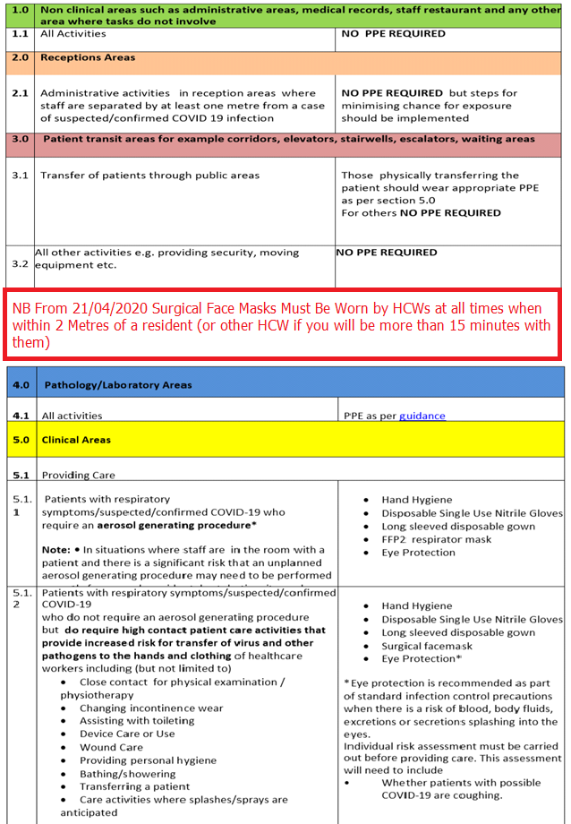
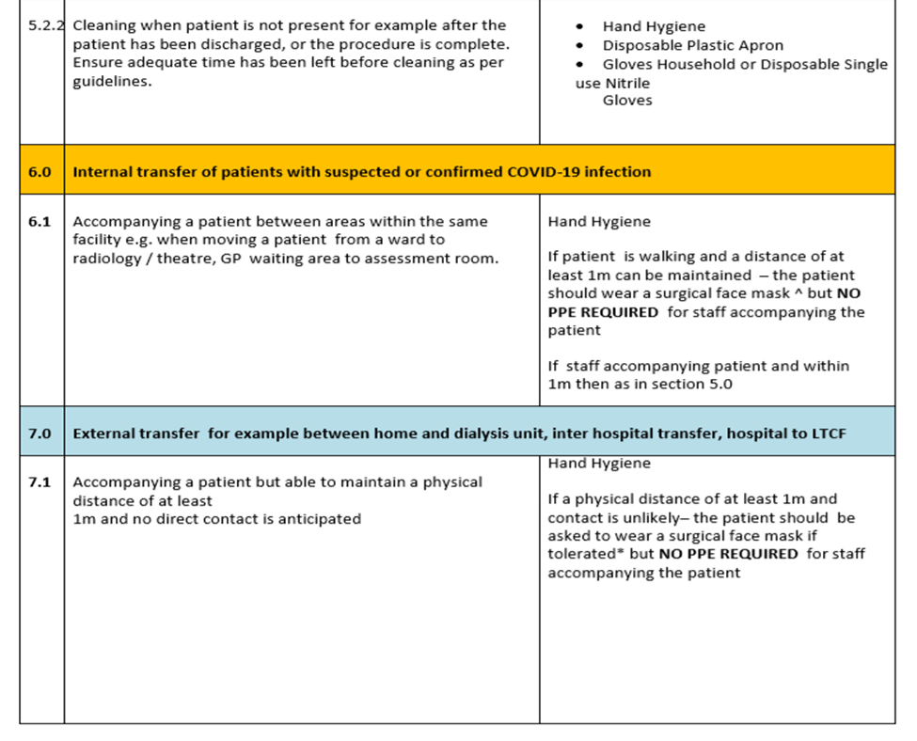
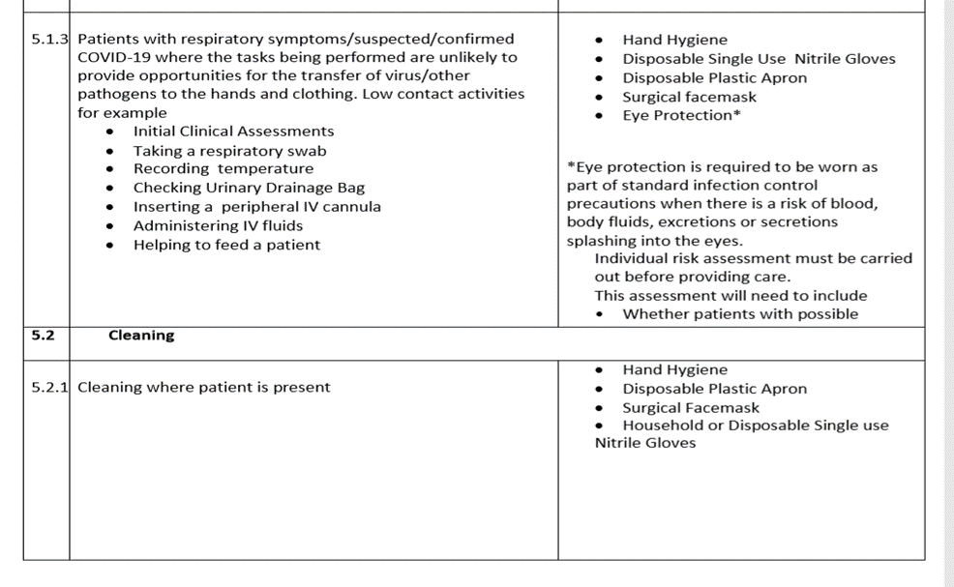

Appendix 2.

Appendix 2 Donning/Doffing PPE.

Appendix 2: Donning and Doffing PPE

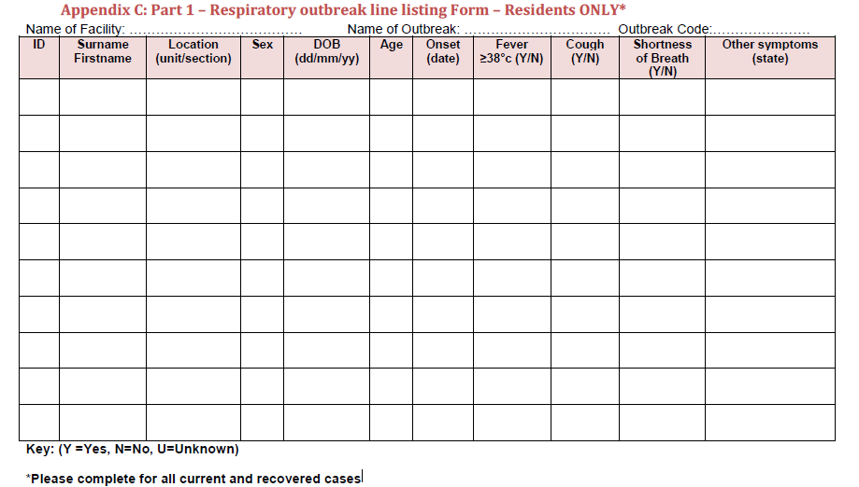

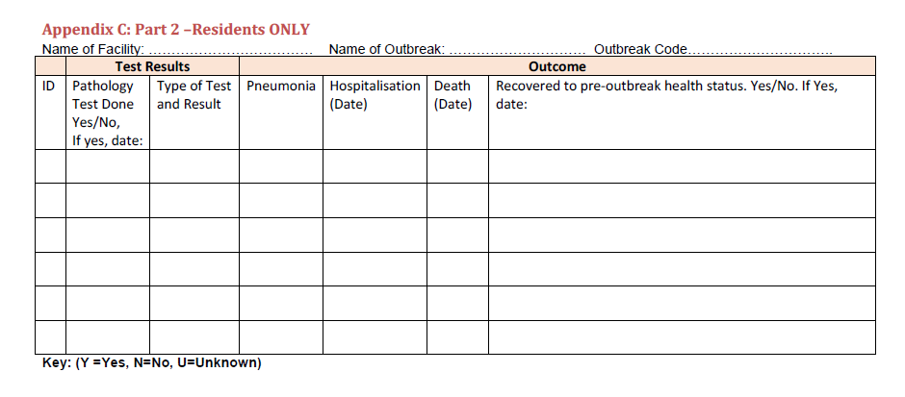

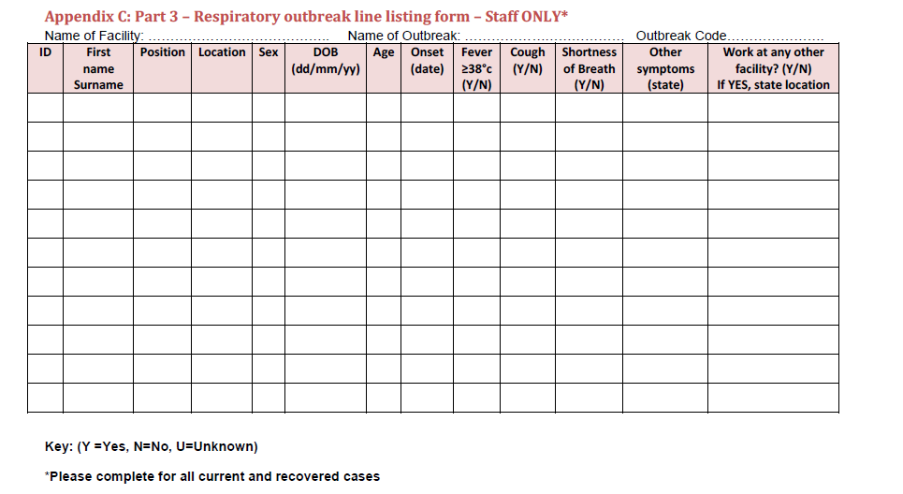

Appendix 4
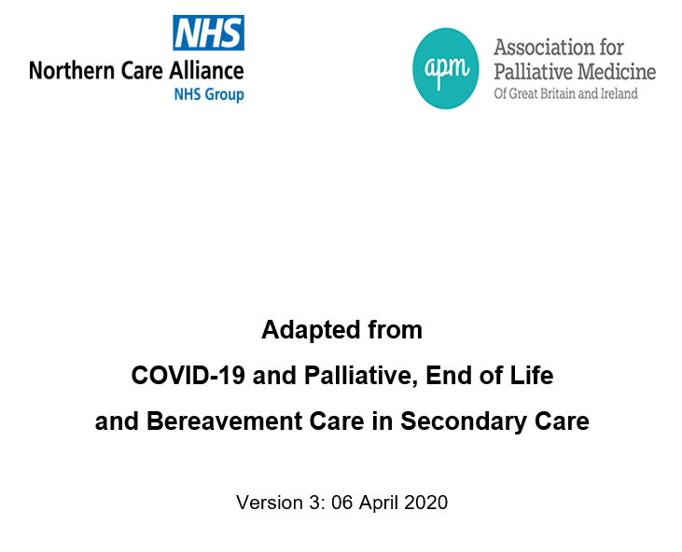

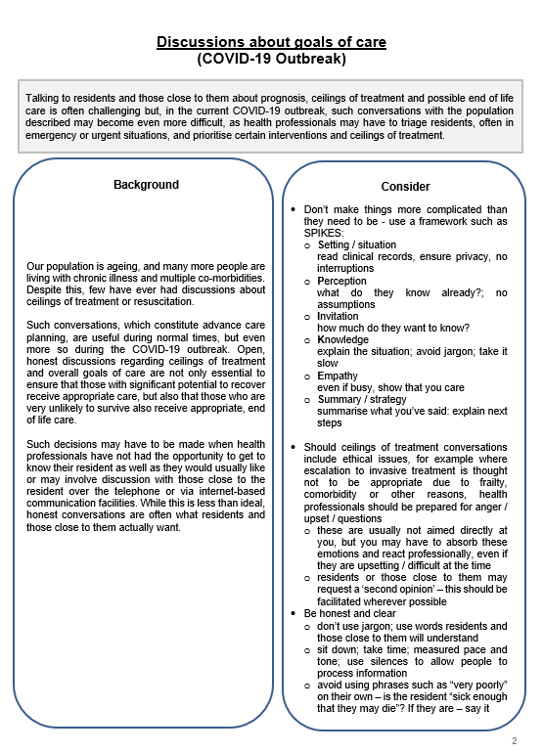
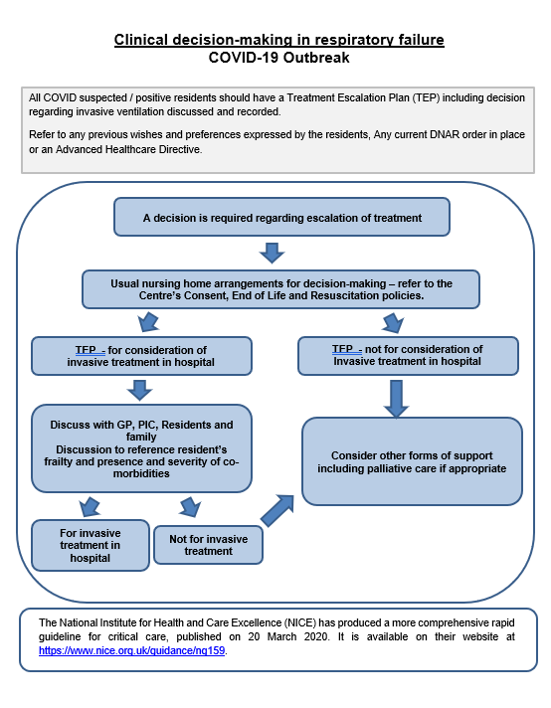
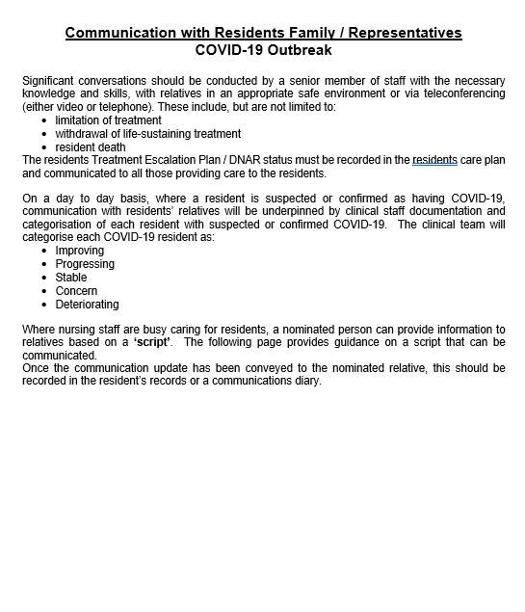

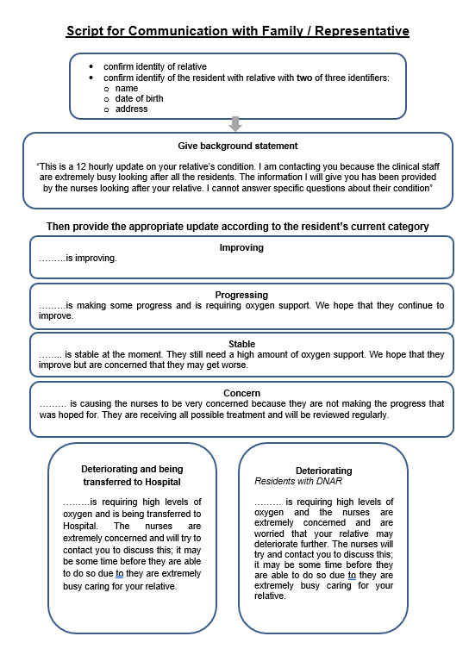
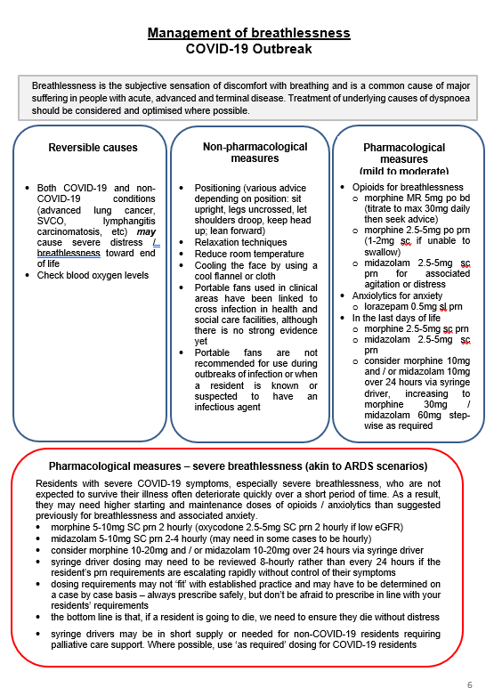
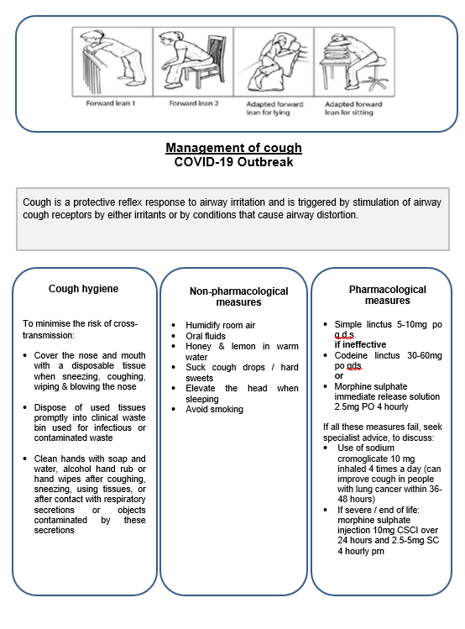
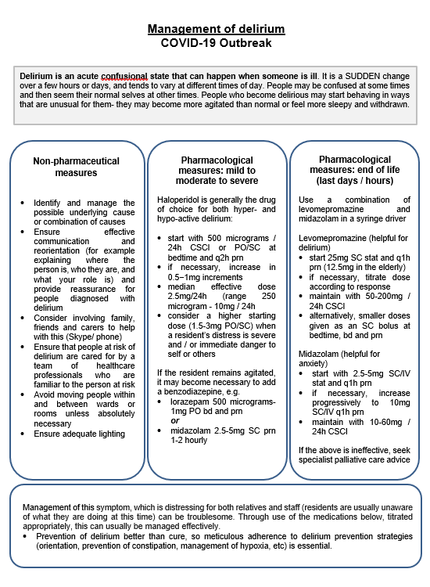
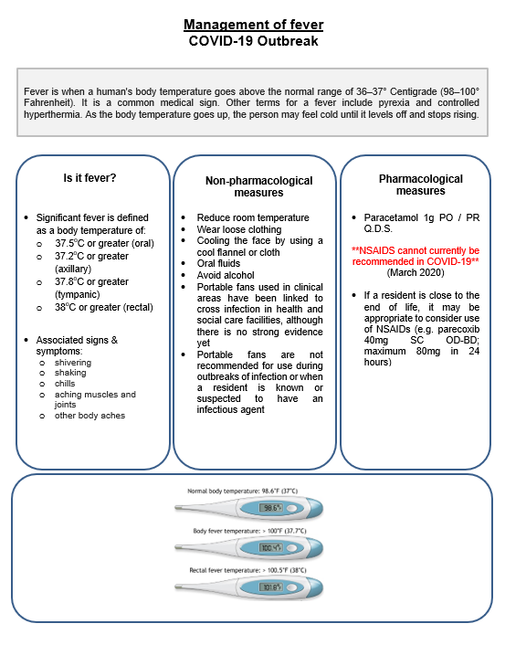
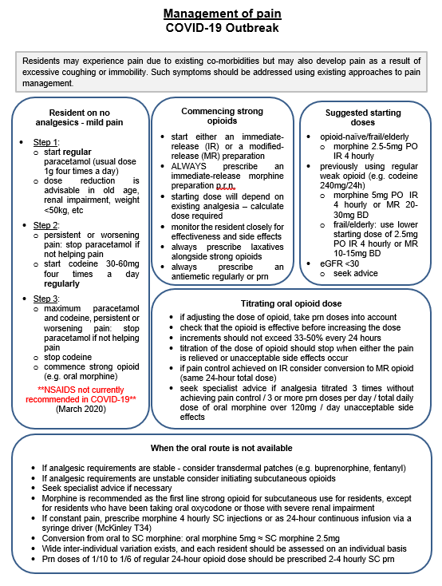
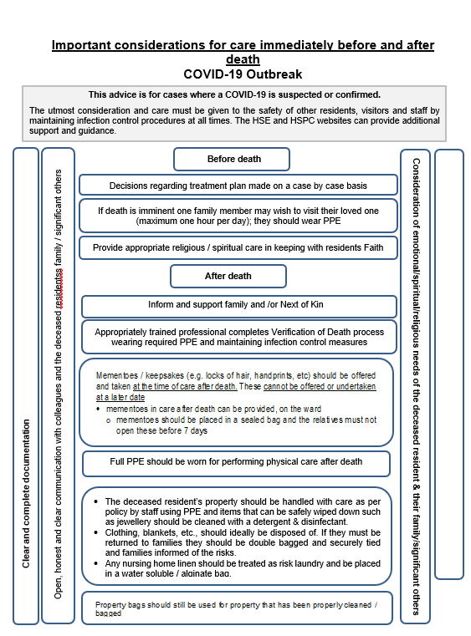
References

Ballentine SM. The Role of Palliative Care in a COVID-19 Pandemic. Shiley Institute for Palliative Care. 2020. https://csupalliativecare.org/palliative-care-and-covid-19/ [Accessed 15 March 2020]

Brighton LJ, Bristowe K. Communication in palliative care: talking about the end of life, before the end of life. Postgrad Med J 2016;92:466–70. https://doi.org/10.1136/postgradmedj-2015-133368

The Choice in End of Life Care Programme Board. What’s important to me: a review of choice in end of life care. London: The Choice in End of Life Care Programme Board, 2015. www.gov.uk/government/publications/choice-in-end-of-life-care [Accessed 29 August 2018]

Clark D, Armstrong M, Allan A, Graham F, Carnon A, Isles C. Imminence of death among hospital in residents: prevalent cohort study. Palliat Med 2014;28:474–9. https://doi.org/10.1177/0269216314526443

Day M. COVID-19: ibuprofen should not be used for managing symptoms, say doctors and scientists. BMJ 2020;368:m1086. https://www.bmj.com/content/368/bmj.m1086 [Accessed 20 March 2020]

Department of Health. The NHS Constitution for England, 27 July 2015. London: DH, 2015. https://assets.publishing.service.gov.uk/government/uploads/system/uploads/attachment_data/file/480482/NHS_Constitution_WEB.pdf [Accessed 29 August 2018]

Flannelly K, Weaver A, Handzo G: A three-year study of chaplains' professional activities at Memorial Sloan-Kettering Cancer Center in New York City. Psychooncology. 2003, 12: 760-768. 10.1002/pon.700

Fogg SL, Weaver AJ, Flannelly KJ, Handzo GF: An analysis of referrals to chaplains in a community hospital in New York over a seven year period. J Pastoral Care Counsel. 2004, 58: 225-235

Galek K, Vanderwerker LC, Flannelly KJ, et al: Topography of referrals to chaplains in the Metropolitan Chaplaincy Study. J Pastoral Care Counsel. 2009, 63 (6): 1-13

Greater Manchester and Eastern Cheshire Strategic Clinical Network. Palliative Care Pain & Symptom Control Guidelines for Adults (5th edn). November 2019. https://www.england.nhs.uk/north-west/wp-content/uploads/sites/48/2020/01/Palliative-Care-Pain-and-Symptom-Control-Guidelines.pdf [Accessed 18 March 2020]

Handzo GF, Flannelly KJ, Kudler T, et al: What do chaplains really do? II. Interventions in the New York Chaplaincy Study. J Health Care Chaplain. 2008, 14: 39-56. 10.1080/08854720802053853

HM Government. The Coronavirus Act 2020. London, HM Government. March 2020. http://www.legislation.gov.uk/ukpga/2020/7/contents/enacted [Accessed 05 April 2020]

National Palliative and End of Life Care Partnership. Ambitions for palliative and end of life care: a national framework for local action 2015–2020. http://endoflifecareambitions.org.uk/wp-content/uploads/2015/09/Ambitions-for-Palliative-and-End-of-Life-Care.pdf [Accessed 18 March 2020]

Osborn M, Lucas S, Stuart R, Swift B, Youd E. Briefing on COVID-19: Autopsy practice relating to possible cases of COVID-19 (2019-nCov, novel coronavirus from China 2019/2020). Royal College of Pathologists, London. 2020. https://www.rcpath.org/uploads/assets/d5e28baf-5789-4b0f-acecfe370eee6223/fe8fa85a-f004-4a0c-81ee4b2b9cd12cbf/Briefing-on-COVID-19-autopsy-Feb-2020.pdf [Accessed 18 March 2020]

Royal College of Physicians. Talking about dying: How to begin honest Conversations about what lies ahead. RCP, London. 2018. https://www.rcplondon.ac.uk/projects/outputs/talking-about-dying-how-begin-honest-conversations-about-what-lies-ahead [Accessed 18 March 2020]

Vanderwerker LC, Flannelly KJ, Galek K, et al: What do chaplains really do? III. Referrals in the New York Chaplaincy Study. J Health Care Chaplain. 2008, 14: 57-73. 10.1080/08854720802053861

Weissman DE, Meier DE: Center to advance palliative care inresident unit operational metrics: consensus recommendations. J Palliat Med. 2009, 12: 21-25. 10.1089/jpm.2008.0210

