Policy Name | Policy for Pronouncement of Death by a Registered Nurse During Covid-19 Emergency.
Code | NMA PDC19
Version: | 1.0
Authors: | Nursing Matters and Associates.
Adapted for local use by:
Issue Date: | 12/05/2020
Review Date:
Authorised by:

Policy Statement.
During the Covid-19 Pandemic pronouncement of death by a registered nurse may be carried out in the centre, for expected deaths where there is a service need identified by the person in charge in agreement with the treating doctor and only in accordance with the criteria outlined in this policy.

Purpose.
The purpose of this policy is to outline the circumstances in which, and criteria that must be met for the pronouncement of death may be carried out by a registered nurse in the centre.

Objectives.

To outline the role and responsibilities of the registered nurse in the safe pronouncement of death in adults over 18.

To outline the circumstances where pronouncement of death could be carried out by a registered nurse in the centre.

To outline the criteria that must be met for the pronouncement of death by a registered nurse in the centre.

Scope.
The policy applies to all registered nurses in the centre during the period of the Covid-19 Emergency period as determined by the Government of Ireland.

Definitions.
Pronouncement of death is the determination, based on physical assessment, that life has ceased, and the subsequent documentation of this determination. Pronouncement of death is defined as deciding whether a person is actually deceased, and it may allow for the removal of the deceased’s remains. Pronouncement of death (as distinct from certification of cause of death) need not be undertaken by a registered doctor. The pronouncement of death is an integral part of the coroner’s death inquiry and a safeguard in that process, (HSE, 30/04/2020).
Expected death is defined by the HSE, (30/04/2020) as death following a period of illness that has been identified as terminal

where registered nurses and doctors have been involved in providing palliative care where there is an agreement between the dying person, those important to the dying person, and medical and nursing teams that no active intervention to prolonging life is ongoing

a ‘Do Not Attempt Resuscitation’ (DNAR) decision has been made, and the decision is recorded in the dying person’s healthcare record and has been communicated to the entire team (HSE, 2017).
Unexpected Death is a death other than an 'expected death' as defined above or a death where there was no expectation that the person was likely to die in the manner or at the time at which they did.
Scope of Practice is the range of roles, functions, responsibilities and activities which a registered nurse or registered midwife is educated, competent and has authority to perform. It can be determined by a number of factors including:

Core definitions and values that underpin nursing and midwifery practice,

Levels of competence,

Channels of responsibility and accountability, and

The supports and resources available.
Scope of practice of an individual nurse is also influenced by a number of factors including:

the nurse’s educational preparation, professional practice and competence; local, national and international guidelines, policies and evidence.

the practice setting.

collaborative practice.

other factors, such as patient safety, patient needs and care outcomes.

Responsibilities.

Person in Charge or Deputy.

The person in charge is responsible for liaising with residents’ medical practitioners to establish the level of service available regarding pronouncement of death where a death occurs in the centre Based on these discussions, the person in charge will identify any deficits to this service and make a decision about the need to implement the Interim Clinical Guidance for the Pronouncement of Death by Registered Nurses in Identified Services in the Context of the Global Covid-19 Pandemic, (HSE, 30/04/2020).

The person in charge is responsible for ensuring that agreements made between residents’ medical practitioners and the centre regarding pronouncement of death by registered nurses are clearly documented to include the outcome of the discussion and the date and time of the discussion.

Where the PIC identifies a service need requiring implementation of this guidance, he/she will ensure that discussions on end of life and the documentation of same have taken place between residents at the advanced stages of a life limiting condition. These discussions should take place between the resident as far as he/she is able, the resident’s representative and the resident’s medical practitioner.

The person in charge is responsible for ensuring that registered nurses have read and understood this policy and the Interim Clinical Guidance for the Pronouncement of Death by Registered Nurses in Identified Services in the Context of the Global Covid-19 Pandemic, (HSE, 30/04/2020) prior to making any decision to extend their scope of practice to include pronouncement of death.

The person in charge will ensure that supports for training, competency achievement and supervision are in place for any registered nurse who extends his/her scope of practice to include pronouncement of death

The person in charge is responsible for ensuring that following the death of a resident the appropriate arrangements, in accordance with that resident’s wishes in so far as they are known and are reasonably practical, are made.

The person in charge is responsible for ensuring that the practice of pronouncement of death by a registered nurse is monitored and audited on a scheduled basis.

The person in charge must ensure that records of completion of training, self assessment and other required documentation related to an individual nurse expanding his/her role to include pronouncement of death are maintained in the nurse’s personnel file.

Registered Nurses.

Registered nurses in the centre have responsibilities relating to end of life care and discussions about end of life care as outlined in the centre’s end of life policy.

For individual nurses, the decision to carry out pronouncement of death in accordance with the Interim Clinical Guidance for the Pronouncement of Death by Registered Nurses in Identified Services in the Context of the Global Covid-19 Pandemic, (HSE, 30/04/2020) is a voluntary decision.

Registered nurses are accountable for making decisions about their scope of practice (NMBI, 2014).

When making decision about scope of practice and in particular in relation to expanding scope of practice, the nurse should ensure that the decision is underpinned by the Scope of Nursing and Midwifery Practice Framework (NMBI, 2015).

The nurse is responsible for making a decision about his/her competence in undertaking the clinical signs used when pronouncing death as well as the recording of pronouncement of death and the supports in place to support the practice.

Each nurse has a responsibility to practice in accordance with the professional Code of Conduct and Ethics, (NMBI, 2014) regarding advanced healthcare directives, the provision of end of life care and care after death.

Protocol for Pronouncement of Death in the Centre by a registered Nurse during the Covid-19 Emergency

Pre-requisites to implementing HSE (30/04/2020) interim guidance.

A service need for the clinical activity is identified.

An agreement has been made between the person in charge and resident’s treating doctors and a record maintained of this.

Existing requirements for the notification of the death to the Coroner and for the treating Doctor to certify the medical cause of death are unchanged.

The registered nurse undertaking this clinical activity has completed the e-learning programme ‘Pronouncement of Death by Registered Nurses in the Context of the Global Covid-19 Pandemic ‘and has successfully passed the associated on-line assessment.

The registered nurse has completed the Self-Assessment of Competency for a Registered Nurse in the Pronouncement of Death in the context of the Global Covid-19 Pandemic (Appendix 3 of the Interim Guidance document). A copy of this completed self-assessment must be discussed with their line manager and a copy logged in their Human Resources file.

In the event that further support is required, the Prerequisite to Pronouncement of Death by a Registered Nurse in the context of the COVID 19 Pandemic has been completed (Appendix 4 of the Interim Guidance document).

Expected Deaths.

In accordance with the centre’s End of Life care policy, all residents who are at the advanced stages of a life limiting illness are given the opportunity to discuss preferences and wishes for end of life care, including preferences and wishes for hospitalization and Cardiopulmonary resuscitation.

In the current emergency, these discussions should include preferences and wishes with each resident as far as each resident is able, about treatment and care in the context of the resident becoming infected with Covid-19.

The discussions about end of life care should take place with the resident as far as he/she is able, the resident’s medical practitioner, the person in charge (or specify) and the resident’s representative where appropriate.

Nursing staff on duty at the time of such discussions should ensure that the resident’s needs for communication are addressed so as to support the resident in making informed decisions.

Discussions and their outcomes about further interventions including cardiopulmonary resuscitation must be clearly documented in the residents’ healthcare record. A Do Not Attempt Resuscitation Order must be recorded, signed and dated by the treating doctor and communicated to the resident’s healthcare team and the resident’s family / representative in accordance with the resident’s wishes.

Where a resident is unable to communicate their wishes and preferences due to a lack of capacity, the resident’s representative should be included in the discussion with the resident’s general medical practitioner/palliative care doctor. The views and observations of the resident’s family/representative will be used to inform decision making by the treating doctor.

Any previous known wishes or preferences expressed by the resident should be used to inform decision making about treatment and care in the event of the resident becoming infected with Covid-19.

The outcome of end of life care discussions must be recorded in the resident’s healthcare record (specify where or completion of form if that is the practice in the centre).

Registered nurses caring for the resident must ensure that any communication needs of relatives are identified and supported throughout the resident’s end of life care journey.

Nursing staff must ensure that the resident’s end of life care plan is updated to reflect the resident’s known wishes and preferences for end of life care, including arrangements for funeral care.

Where a resident is dying, where possible the nurse should liaise with the resident’s representative about contact the funeral director in advance of the resident’s death (HSE, 30/04/2020).

Visitors.

The presence of a person close to the resident should be facilitated in so far as it is possible.

Visitors must be informed of the potential infection risk.

Where the resident or family requests the presence of a member of the pastoral care team who is willing to attend, this should be facilitated.

All persons in attendance should be advised to wear a surgical mask and plastic apron.

Gloves are not essential so long as those in attendance understand the risks, perform hand hygiene after touching the person and before leaving the room.

Visitors should be instructed on how to put on and take off the PPE & how to perform hand hygiene.

A member of nursing staff should escort visitors to and from the resident’s room and assist and supervise visitors when donning and doffing PPE.

For the anointing of the sick or other rites where only transient physical contact is required, gloves are not necessary so long as hand hygiene is performed immediately after anointing or touching the person.

Visitors should avoid contact with people other than the person they are accompanying

Unexpected Deaths.

In the event of an unexpected death of a resident, the registered nurse should make all reasonable efforts to resuscitate the resident in accordance with the centre’s resuscitation policy and Covid-19 cardiopulmonary resuscitation guidance from the Health Services Executive, (2020) See Appendices 1 and 2.

The emergency ambulance must be called.

Where there are unnatural signs of death, such as trauma or unexplained injury, the nurse must contact an Garda Siochána who will liaise with the coroner, treating doctor and funeral directors.

In all other cases of unexpected death, the nurse must contact the resident’s treating doctor and the coroner who will advise accordingly.

All deaths that occur in the centre are reported to the coroner as outlined in the centre’s End of Life Care Policy.

Procedure for Pronouncement of Death by a Registered Nurse during Covid-19 Emergency.

Pronouncement of death by a registered nurse in the centre can only be carried out for expected deaths, which are:

death following a period of illness that has been identified as terminal

where registered nurses and doctors have been involved in providing palliative care

where there is an agreement between the dying person, those important to the dying person, and medical and nursing teams that no active intervention to prolonging life is ongoing

a ‘Do Not Attempt Resuscitation’ (DNAR) decision has been made, and the decision is recorded in the dying person’s healthcare record and has been communicated to the entire team (HSE, 2017).

The nurse should comply with any infection prevention and control precautions in place prior to the resident’s death.

The nurse must check for the following clinical signs of death using a stethoscope and penlight or ophthalmoscope:
- Absence of a carotid pulse for over one minute.
- Absence of heart sounds for over one minute.
- Absence of respiratory movements and breath sounds for over one minute.
- Fixed pupils, unresponsive to bright light.
- No response to painful stimuli, such as sternal rub or trapezius pinch.

Where the above clinical signs of death are present, the nurse should record this in section 2 of the ‘Pronouncement of Death by Registered Nurse Form’, noting date and time.

The nurse should then repeat the check for clinical signs of death after 10 mins and record same in section 2 of the form, noting date and time.

If there is any uncertainty, the nurse should repeat the steps within 30 minutes of the initial assessment.

If after 30 minutes, there is still uncertainty, the nurse should confer with a colleague.

When clinical signs of death have been established, the nurse should note and document the time of death. The time of death is recorded as the time that the first check of the signs of death were completed (HSEland e-learning programme ‘Pronouncement of Death by Registered Nurses in the Context of the Global Covid-19 Pandemic, 2/05/2020).

When pronouncing death, the registered nurse must record the following details on the ‘Pronouncement of Death by a Registered Nurse Form’:

The date and approximate time of death.

Name and date of birth of the deceased.

Date and time of pronouncement.

Name of the doctor informed, and the time and date that this took place (it is imperative that this is the doctor who will certify the death).

Name of the coroner informed and the time and date that this took place.

Name of those important to the dying person informed.

Name of funeral director, if contacted, and any details relating to this contact.

Name of pastoral support if contacted and any details relating to this contact.

Communication Protocol Following Pronouncement of Expected Death.

The occurrence and circumstances of the resident’s death must, as soon as possible be formally communicated by direct telephone contact to the treating doctor using the SBAR communication tool (Appendix 3)

If the treating doctor states that he/she satisfied that death has occurred as expected and that he/she will issue the death certification form, this must be recorded by the nurse on the ‘R’ section of the ISBAR form.

If the treating doctor is not satisfied that death occurred as expected, any instructions from the treating doctor, including his/her request/intention to examine the body must be recorded in the ‘R’ section of the SBAR form.

Once the death has been pronounced, the nurse will formally communicate with the coroner as per 8.2

Care of the deceased’s body should be carried out as per 8.2

The registered nurse should contact the resident’s family/representative as outlined in 8.3

If, after the death has been pronounced, a change in circumstances arises which affects the operation or applicability of this policy (for example a decision is taken that the deceased person’s remains are for cremation or for donation to medical science) the body must not be removed from the place of death without a treating doctor’s consent. The treating doctor is required to view the body in order to complete the necessary documentation (HSE, 30/04/2020).

The person in charge or deputy will contact all professionals involved in the care of the dying person, so that they are aware of the death.

Notifying the Coroner.

Following pronouncement of the death of a resident the nurse must contact the Coroner’s office.

[Enter Coroners details here]

The nurse should inform the coroner that he/she pronounced the death of the resident and the time the death was pronounced. He/she should inform the coroner that the treating doctor states he/she is satisfied that the death occurred as expected and that the body can be removed by the funeral director.

The resident’s body should not be removed from the Centre without permission from the coroner that the body can be released.

The body can only be laid straight until it is released by the coroner. All tubes, catheters and medical equipment must not be removed until the coroner grants permission to do so.

The resident’s medications must be kept until such time as the coroner grants permission to dispose of them.

No funeral arrangements, removal of tubes/catheters, or removal of the body from the Centre is permitted until the coroner is notified, and permission to proceed with funeral arrangements given.

The Coroner may ask to speak with the last General Practitioner to see the resident alive. If this occurs during regular working hours (Monday – Friday, 9am - 5pm) [Enter local arrangements with GP] the person in charge / nurse on duty should inform the General Practitioner.

If the death occurs outside of normal hours (Friday 5pm – Monday 9am), it may be necessary to hold the body in the Centre until the Coroner has spoken with the General Practitioner who last saw the resident alive.

Alternatively, following consultation with the Coroner, the body may be removed to the funeral home on the condition that the body remains untouched/ no preparations for burial take place.

The Coroner’s office will ask the name of the deceased, date of birth, date of death, length of stay, diagnosis, and care given whilst in the Centre.

The coroner reviews each case individually based on the information given by the nursing staff and the General Practitioner

In some cases, the coroner may order a postmortem to define the exact cause of death.

The resident’s family should be informed of the Coroner’s guidelines and reason for the procedure.

Informing relatives of the death by telephone

If the resident’s family or next of kin is not present at the time of death inform them as soon as possible.

Giving of bad news over the phone demands great sensitivity, particularly if the death is unexpected. Each situation is unique and needs to be assessed on an individual basis. The Irish Heart Foundation has resources including a fact sheet to support healthcare professionals with giving bad news https://hospicefoundation.ie/wp-content/uploads/2020/05/Delivering-Bad-News-COVID19.pdf

Even where death is expected relatives may experience shock.

Relatives may also be particularly upset that they were not there at the time.

Prior to making the call the nurse must ensure he/she has accurate information.

If the person listed as next of kin is elderly and lives alone it may be necessary to contact another person first. For this reason, it is always useful to have two or three contacts to ring and (leading up to the death), it is best to clarify/agree who should be contacted first, second and third in an emergency.

The most senior nurse on duty should make the call, ensuring sufficient time and privacy for same.

The nurse making the call should introduce him/herself using full name and position and where he/she is ringing from.

The name of the person being spoken with should be confirmed and his/her relationship to the resident, if this is not known.

The nurse should ascertain if there is someone with the relative and offer to speak to them also.

It may be best to ask the person to sit down.

To give some warning that the person is about to be given bad news the conversation could begin with “I am very sorry, but I have some bad news to tell you”. The nurse should use clear language to avoid confusion while always remaining sensitive.

If the death was unexpected the nurse might continue by gently informing the person that their relative’s condition had deteriorated, and they had died.

It is important to remember that the person may be in shock and very distressed.

The nurse should allow time and answer any questions sensitively and honestly. It may be necessary to repeat information as the person may find it very difficult to take in what is being said.

The person should be given information about what will happen next and the nurse should continue to answer any questions the person may have.

The nurse should stay on the phone until the person indicates they are ready to finish the conversation.

Offer to contact someone on their behalf if necessary.

Ascertain their wishes about coming to the Centre. (Consider the practicalities of travel arrangements (it may be unwise to drive, parking on arrival, who will meet them and where)

Acknowledge how difficult receiving this call is and that perhaps he/she needs to take a little time, have a cup of tea, have someone sit with them for a while before travelling into the Centre.

Give the person a contact name and number to write down and encourage them to call if they wish.

If they are not contactable by telephone inform their local Gardai who will try to alert them. Ensure the Gardai are aware if they are going to an elderly person or someone living on their own.

Ensure that light refreshments are served to relatives on arrival.

Protocol following an unexpected death.

The occurrence and circumstances of the resident’s death must, as soon as possible be formally communicated by direct telephone contact to the treating doctor using the SBAR communication tool (Appendix .3.)

The treating doctor will liaise with the coroner and they will advise the registered nurse on any further steps to be taken such as:
a) Proceed to pronouncement of death and transfer to the care of the funeral director
b) A further medical examination of the body is required.

If there is evidence of trauma or injury to the deceased body the registered nurse MUST contact an Garda Siochána who will then liaise with the coroner, the treating doctor and the funeral director. The registered nurse will abandon the pronouncement of death procedure and complete Section 4 on the ‘Pronouncement of Death by a Registered Nurse Form’

Care of the deceased’s body should be carried out as per 8.2.

The registered nurse should contact the resident’s family/representative as outlined in 8.3.

If, after the death has been pronounced, a change in circumstances arises which affects the operation or applicability of this policy (for example a decision is taken that the deceased person’s remains are for cremation or for donation to medical science) the body must not be removed from the place of death without a treating doctor’s consent. The treating doctor is required to view the body in order to complete the necessary documentation (HSE, 30/04/2020).

The person in charge or deputy will contact all professionals involved in the care of the dying person, so that they are aware of the death.

References.
- Health Services Executive, (31/04/2020) interim clinical guidance for the pronouncement of death by registered nurses in identified services in the context of the global covid-19 pandemic
- Coroner Society of Ireland Guidance in relation to the Coroners Service and Deaths due to Covid-19 infection Version 6: 19/4/2020 http://www.coroners.ie/en/COR/Coroners%20Service%20Guidance%20Covid-19%20Version%206%20FINAL%20190420.pdf/Files/Coroners%20Service%20Guidance%20Covid-19%20Version%206%20FINAL%20190420.pdf
- Coroners Society of Ireland Modified Requirements for Death Pronouncement in Coroners’ Cases during Covid-19 Pandemic Version 2: 28th April 2020.
http://www.coroners.ie/en/COR/Pronouncement%20Document%20Version%202%20FINAL%20Approved%2028%20April%202020.pdf/Files/Pronouncement%20Document%20Version%202%20FINAL%20Approved%2028%20April%202020.pdf
- Irish Hospice Foundation, (2020) Delivering Bad News – Covid 19 https://hospicefoundation.ie/wp-content/uploads/2020/05/Delivering-Bad-News-COVID19.pdf
- Health Protection and Surveillance Centre Interim Public Health and Infection Prevention Control Guidelines on the Prevention and Management of COVID-19 Cases and Outbreaks in Residential Care Facilities and Similar Units V4.1 04/05/20
https://www.hpsc.ie/a-z/respiratory/coronavirus/novelcoronavirus/guidance/infectionpreventionandcontrolguidance/residentialcarefacilities/Preliminary%20RCF%20guidance%20document.pdf

Appendix 1. CPR Guidance for Confirmed or Suspected Covid 19 in Residential Care Facilities DPIP | V1 23rd April
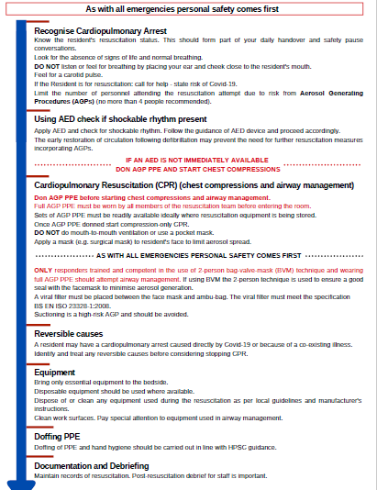
Appendix 2: CONFIRMED/SUSPECTED COVID-19 GUIDANCE ON CPR IN RESIDENTIAL CARE FACILITIES
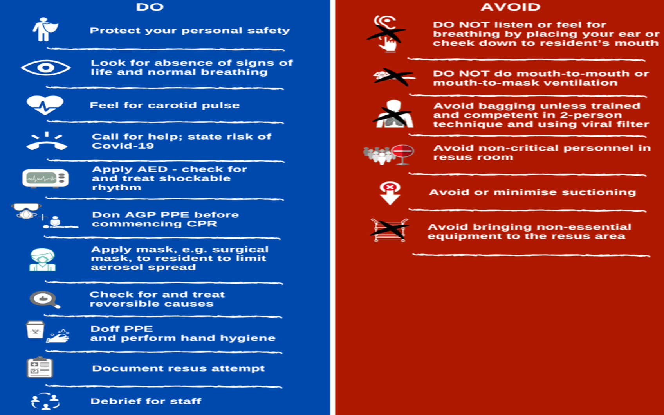
Appendix 3: Sample SBAR Communication Tool.
Situation | My name is Mary Brown. I am a staff nurse at the Sycamore Nursing Home.
John Smith, date of birth 10th March 1934 passed away at 6.10am.
I have completed the Pronouncement of Death by a Registered Nurse Form. John Smith has died.
Background | What is the clinical background?  You saw John 5 days ago on the 2nd of the month. He had a Do Not Attempt Resuscitation Order Completed.
Assessment | Do you wish to view the body? Are you satisfied that death occurred as expected? Will you complete the death notification form? Can the body now be removed by the Funeral Director?
Recommendation | What would I recommend or request?  Dr. …. Stated that he is satisfied that death occurred as expected and will complete the certification of death.  The coroner must be contacted an informed of the death and that the treating doctor is satisfied that the death occurred as expected and will complete the certification of death. This conversation must be recorded in the healthcare record.

